Unified Transformer-Based Spatio-Temporal Forecasting of Air Quality and Urban Noise Risk with a Rule-Based Public Advisory Layer
Akella S. Narasimha Raju^{1*}, Shovik Banerjee², Kaushani Chakraborty³, Venkataramana Guntreddi^{4*}
¹Department of Computing Technologies, School of computing, College of Engineering & Technology, SRM Institute of Science and Technology, Kattankulathur, Chennai, Tamilnadu,603203, akellar@srmist.edu.in
²Department of Computing Technologies, School of computing, College of Engineering & Technology, SRM Institute of Science and Technology, Kattankulathur, Chennai, Tamilnadu,603203, sb6935@srmist.edu.in
³Department of Computing Technologies, School of computing, College of Engineering & Technology, SRM Institute of Science and Technology, Kattankulathur, Chennai, Tamilnadu,603203, kc7009@srmist.edu.in
⁴Department of Electrical, Telecommunication and Computer Engineering, School of Engineering and Applied Science, Kampala International University, Western Campus, Bushenyi, Uganda , gvramana@kiu.ac.ug
*Corresponding author: Akella S Narasimha Raju (email: akella.raju@gmail.com ), Venkataramana Guntreddi(akellar@srmist.edu.in)

Abstract
The accelerated pace of urbanization increases air pollution and environmental noise, resulting in a set of interrelated exposure issues that require the development of forecasting systems with the ability to provide accurate predictions and public advisories. The current literature often considers air quality index (AQI) and noise pollution separately; noise pollution is modeled as a continuous regression task despite its event-oriented nature and low monthly autocorrelation, making it less useful for decision-making. We propose an attention-driven spatio-temporal model that combines government-provided AQI data with diurnal and nocturnal noise pollution measurements into a single monthly dataset, extends it with lagged and rolling features, and compares Linear Regression, XGBoost, and convolutional neural network (CNN) models with several transformer models: a standard Transformer (ReLU/GELU activation functions), a Hybrid Convolution-Attention Transformer, and a simplified Temporal Fusion Transformer. The AQI is predicted using regression analysis, while noise pollution is recast as a risk classification problem to provide probabilities amenable to decision-making. An inference rule layer is used to translate predicted AQI values and noise risk scores into actionable warnings for both daytime and nighttime scenarios. The results show that transformer models provide a consistent boost to AQI prediction accuracy, with the Hybrid Convolution-Attention Transformer providing R² = 0.91 and MAE ≈ 8.7 on the combined dataset, outperforming non-attention and traditional models. In contrast, direct noise pollution regression is plagued by model-wide instability; recasting noise pollution as a classification problem improves discriminative accuracy, reaching an AUROC of ≈ 0.63 for nighttime scenarios and achieving competitive probabilistic errors (log loss/Brier score). The system provides a realistic exposure guidance framework for city-scale scenarios by integrating transformer-based predictions with decision-oriented risk outputs.
Keywords: Air Quality Index Forecasting; Urban Noise Risk; Spatio-Temporal Transformers; Hybrid Convolution–Attention; Rule-Based Public Advisory
- INTRODUCTION
We have identified air pollution and environmental noise as two stressors that have been exacerbated by modern urbanization and industrialization. The World Health Organization estimates that the attributable risk of household and ambient air pollution leads to 6.7 million excess deaths each year. A large number of these excess deaths occur in populations exposed to traffic-related gases and fine particulate matter through cardiopulmonary routes. [1], [3] According to the Health Effects Institute and the State of Global Air initiative, air pollution led to 8.1 million deaths in 2021, stressing that air pollution in urban areas is not only an environmental problem but also a significant health risk. The problem of air pollution, as indicated by air quality scores, is particularly significant in urban areas where air pollution is further aggravated by transportation and industrial emissions. The problem of air pollution, as evidenced by air quality values, is particularly acute in urban areas, where air pollution is caused by transportation and industrial emissions. Environmental noise is now recognized as a serious health problem, similar in importance to air pollution, due to its large non-auditory health effects.
Besides air pollution, environmental noise is gradually recognized as a significant public health risk with significant non-auditory effects. The WHO Regional Office for Europe summarizes the evidence regarding the effect of chronic exposure to environmental noise on outcomes such as sleep disturbance, cardiovascular and metabolic disease, cognitive impairment, and mental health and well-being. [4] In keeping with WHO guidance, there is a general appreciation that excessive noise exposure increases the risk of ischemic heart disease and hypertension and is associated with adverse outcomes independent of annoyance. [5] Importantly, urban noise patterns are often event-related (traffic bursts, construction phases, rhythms of socio-economic activity) with low persistence on a coarse timescale; there is mechanistic and clinical evidence that nocturnal noise exposure can affect sleep architecture and trigger a detectable stress response. As such, decision-support modeling should be structured around risk strata rather than regression on a continuous variable. [6]
From a modelling viewpoint, the conventional air quality forecasting chain has conventionally depended on statistical baselines and tree-based machine learning models (e.g. XGBoost), which are known to work well in stationary environments but are often expected to be less robust under conditions of non-stationarity, covariate heterogeneity, and cross-city generalization. [7] CNN-based models improve short-term feature learning, but they can still be insufficient for long-term dependency modelling in spatio-temporal environmental phenomena—exactly what the transformer attention mechanism is best suited for. Recent studies on air quality forecasting have started to leverage transformer modules for time series forecasting, such as transformer hybrids in Scientific Reports (2024) and multi-granularity spatiotemporal fusion transformers in Information Fusion (2025), which indicate the increasing trend of attention-based air quality forecasting. [8], [9] Nevertheless, the comprehensive modelling of both AQI forecasting and urban noise as a dynamic risk signal, and addressing the modelling challenges of temporal resolution mismatch and autocorrelation in noise, is still an open problem. Based on the original transformer model formulation introduced by Ashish Vaswani et al. and using interpretable multi-horizon models like Temporal Fusion Transformers, this paper proposes an attention-based framework that models AQI forecasting as a regression problem, models noise as a risk classification problem, and closes the loop with a rule-based public recommender that converts forecasts of severity (and sources) into actionable mitigation advice. [10], [11]
- LITERATURE SURVEY
Air quality forecasting has evolved from statistical and ensemble machine learning methods to spatio-temporal deep learning and transformer models in previous work. However, most of the previous work still cast pollution forecasting as a static classification problem or a single-modality forecasting task. Previous work shows the effectiveness of city-scale AQI/APSI classification using Random Forests, such as the Jakarta APSI forecast with about 95% accuracy. However, these studies are restricted to a single city and time period, are not temporally aware, and analyze samples independently without incorporating weather or acoustic information [12]. Traditional baselines are set up through multi-city analysis of large-scale hourly AQI datasets using Decision Trees, SVM, and Random Forest. However, time series are still considered static data, and the best accuracy is only about 74%, leading to poor modeling of diurnal/seasonal and long-term dependencies [13]. Spatio-temporal deep learning improves short-term forecasting by modeling spatial dependencies (e.g., graph convolution for multi-step PM2.5 forecasting with R²≈0.949). However, it is often restricted to small sets of stations and focuses on pollutant regression instead of multi-factor urban risk modeling [14]. Local AQI classification using RF/XGBoost can reach an accuracy of 95-96% but are mostly descriptive and lack forecasting capabilities, as well as the geospatial/temporal embeddings required for transfer learning [15]. Transformer models, such as AirFormer, have shown strong nationwide spatio-temporal attention for PM2.5 forecasting at a large scale (R²≈0.949) with interpretability through attention mechanisms, but are mostly tested in a single-country setting and remain air and weather focused [16]. Recently proposed inverted-attention spatio-temporal transformers (ST-iTransformer) handle non-stationarity and spatial embedding; however, they still ignore noise, source drivers (traffic/industry), and real-time scalability validation beyond a limited geographical region [17]. Moreover, operational data infrastructures (e.g., CPCB AQI/monitoring websites and ENVIS-linked data repositories) offer broad contaminant coverage and potential noise-monitoring data; however, they are seldom combined into a single deployable modelling framework [18], [19]. Traditional noise research indicates that environmental noise is extremely context/event-driven and demands specific measurement and analysis (e.g., roadside-construction noise and campus noise). Therefore, noise needs to be modelled as a risk classification with weak autocorrelation rather than as a static feature [20], [21]. Finally, the applicability of attention-based sequence models for long-range dependencies has matured, as shown by cross-domain spatio-temporal transformers in weather forecasting, which inspires the need for unified transformer pipelines for robust and generalizable urban environmental intelligence [22]. Table 1 contains a comprehensive comparison table for the literature survey.
Table 1. This has the extensive research survey of literature.
S.No | Ref. | First Author | Year | Methodology | Dataset | Performance (reported) | Key strengths | Key limitations | Research gap to close
1 | [12] | Richie Muljana | 2023 | Random Forest classifier + feature importance for APSI | Jakarta Open Data (single city, single year) | ~95% accuracy (classification) | Strong baseline; interpretable pollutant ranking | No temporal dependency modelling; single-city/year; no meteo/noise | Sequence learning + cross-city generalisation + multimodal fusion (air+noise+weather)
2 | [13] | K. M. O. V. K. Kekulunadara | 2021 | DT / SVM / RF comparison for AQI | Multi-city India hourly AQI (100k+ records) | ~74% max accuracy | Large-scale baseline comparison | Treats time-series as static; no DL/transformers; no meteo/noise | Long-range temporal modelling + better feature context + decision-grade outputs
3 | [14] | Hong Cheng | 2024 | STSGCN multi-step PM2.5 forecasting | 8 stations, Wuhan (2018–2022) | R²≈0.949; RMSE≈3.39 | Explicit spatio-temporal dependency modelling | Limited stations; mainly short-term; PM2.5-only; no noise/source | Multi-factor urban intelligence (AQI + noise risk + source attribution) + broader generalisation
4 | [15] | Priyanshi Kotlia | 2024 | RF & XGBoost AQI classification | Uttarakhand districts | RF≈96%, XGB≈95% accuracy | High accuracy; pollutant importance | Static classification; no forecasting; limited geography | Forecasting + geospatial embeddings + cross-region transfer
5 | [16] | Yuxuan Liang | 2023 | Transformer (AirFormer) with dynamic spatio-temporal attention | 1,085 AQ + 2,575 meteo stations (China, 2015–2018) | R²≈0.949; MAE≈16.03 | Long-range modelling; attention explainability | No noise integration; country-specific training | Unified air+noise modelling + cross-city/cross-country robustness + action mapping
6 | [17] | Rui Zhang | 2025 | ST-iTransformer (inverted attention + geo embeddings) | Beijing multi-site (UCI), 12 stations | High accuracy (paper-reported) | Targets non-stationarity; spatio-temporal embeddings | No noise/traffic/industry; scalability/real-time validation limited | Practical deployability + multimodal drivers + calibrated decision support
7 | [18] | Central Pollution Control Board | — | National AQI / monitoring portals (CAAQMS/NAMP access points) | India-wide monitoring network | — | Authoritative operational data access | Not directly model-ready; heterogeneity/missingness | Harmonised data engineering + resolution alignment for unified modelling
8 | [19] | ENVIS/CPCB-linked repositories | — | Environmental information repositories | India environmental data ecosystems | — | Supports pollutant + (often) noise datasets | Fragmented, underused in unified models | Joint learning across air+noise with consistent schema & governance
9 | [20] | Haizhen Zhang | 2011 | Environmental noise measurement + evaluation | Campus setting (Southwest Forestry Univ.) | — | Highlights measurement protocol + day/night variation | Not predictive; local study | Noise as dynamic risk signal; classification framing; integration with AQI forecasts
10 | [21] | Jun Zhang | 2010 | Roadside construction noise analysis | Urban road near construction | — | Event-driven noise behaviour evidence | Not predictive; context-specific | Event-driven noise modelling + risk thresholds for public recommendations
11 | [22] | Junzhong Ji | 2025 | Spatio-temporal transformer for forecasting (cross-domain evidence) | Weather forecasting benchmarks | Strong forecasting (journal-reported) | Validates attention for long-range spatio-temporal learning | Different domain (weather) | Transfer spatio-temporal transformer design to air+noise unified forecasting
  - Research gap
Despite the progress made in air quality forecasting, ranging from statistical and traditional machine learning models to spatio-temporal deep learning and transformer architectures, there is still a gap in the literature that needs to be filled: there is no integrated, ready-to-deploy system that tackles both AQI forecasting and urban noise as a dynamic risk indicator in a single, combined framework that can generalize well across multiple cities and express results in a form of actionable public advice. Most of the existing literature is air-focused (and, in some cases, air-only and weather-only), geographically constrained to small regions or air quality stations, and ends with accuracy metrics without considering real-world data problems such as resolution mismatches, missing data, and nonstationarity. More importantly, they overlook the fact that urban noise is an event-driven process with weak autocorrelation at a coarse temporal granularity, making direct regression problematic and instead requiring a decision-support reformulation as a day/night risk classification problem rather than a continuous value prediction task. Moreover, pollution source attribution (traffic, industrial, event-related) and decision transparency through a rule-based recommender system that expresses model predictions in an auditable form interpretable to the public are not typically integrated with the existing pipelines. The proposed project will fill this gap by developing a spatio-temporal transformer pipeline based on attention-driven mechanisms. This pipeline will be responsible for AQI forecasting as a regression task, noise prediction as a calibrated risk classification problem, ensure multi-city harmonization and evaluation on a consistent basis, and feature a rule-based public recommender system that expresses predicted risk severity (and source information) in actionable mitigation advice.
  - Technologies Utilized
This research uses a spatio-temporal modeling toolkit that is attention-driven and Transformer-based (ranging from the Vanilla Transformer with ReLU/GELU activation functions to the Hybrid Convolution-Attention Transformer and a Temporal Fusion Transformer-inspired model architecture). The model is fine-tuned against machine learning benchmarks (Linear Regression, Random Forest, SVM, XGBoost) and a CNN model for sequence learning with long-range dependencies. The data processing pipeline involves spatio-temporal harmonization, lag/rolling feature construction, and, where applicable, geographical/contextual embeddings. Air Quality Index (AQI) is formulated as a regression forecasting task, while noise is formulated as a day/night risk classification problem with probabilistic assessment metrics (such as AUROC, log loss, or Brier score). The final decision component includes an auditable rule-based recommender system that converts forecasted AQI and noise risk probabilities into actionable public warnings, with interpretability facilitated through attention-explained and feature importance analyses.
- METHODOLOGY
The proposed methodology is an attention-driven, three-stage spatio-temporal learning and decision-support process, and it includes the following: (i) Data Collection and Preparation, where the air/noise (and contextual) data is cleaned, synchronized, normalized, and converted to sequence-ready spatio-temporal features; (ii) Model Comparison and Selection, where several transformer models are trained using the same input protocol and assessed using task-specific metrics to determine the most resilient configuration; and (iii) Operational Decision Support, where the results of the selected model are combined with explainability and an alert/recommender component to provide interpretable, user-friendly advisories. The proposed methodology is depicted in Figure. 1. The demonstrated ability of attention mechanisms to model long-range temporal dependencies and spatial interactions in environmental time series is the foundation of the proposed architecture. This ability has been demonstrated in transformer-based air quality prediction [16] and spatio-temporal transformer forecasting [22].
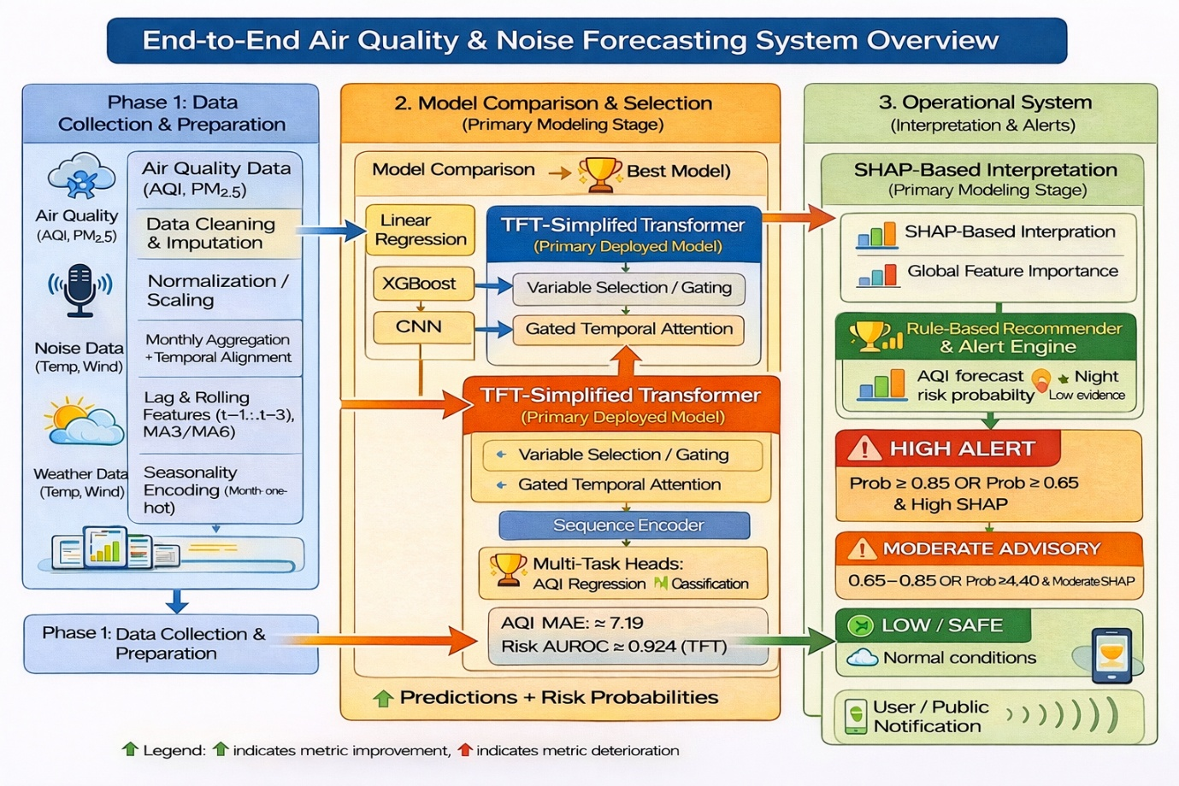
Figure 1 Architecture Diagram: Air Quality and Noise Forecasting System
  - Phase 1 — Data Collection and Preparation
The strategy for data ingestion and unification is shown in Figure 2. Two government-provided urban monitoring datasets, Air Quality Data in India (2015-2020) and Noise Monitoring Data in India (2011-2018), are unified into a single spatio-temporal learning dataset by combining hourly/daily station-level pollutant concentration data with calculated AQI values for multiple Indian cities, and monthly station-level decibel values for Indian cities, respectively. The noise dataset offers day/night exposure surrogates for risk modeling, while the air dataset offers the pollutant/AQI framework for forecasting. Both datasets can be traced back to the CPCB monitoring infrastructure and respective dissemination platforms, thus allowing a common provenance story to be told for the unified dataset. [23]–[26] Because of the two datasets’ natural sampling rates (hourly/daily vs. monthly), the processing pipeline uses monthly aggregation as the common time unit to synchronize the timestamps, filter out high-frequency noise from the sensors, and retain long-term exposure patterns for spatio-temporal forecasting and risk analysis. [23], [24]
In order to provide numerical stability and sequence integrity for transformer model training, a unified and consistent preprocessing pipeline is applied to the unified dataset after temporal synchronization. Specifically, statistically informed imputation is employed for missing values, outlier filtering helps to mitigate the effect of rare value gradients, and all continuous variables are normalized to a common scale for better convergence and conditioning in deep models. [27] This provides a unified spatio-temporal feature matrix ready for modeling. The AQI/pollutants and noise variables are unified under a common framework, allowing for model comparison across baselines and transformer variants without training instability caused by heterogeneous units, discontinuities, and distributional biases. [27].
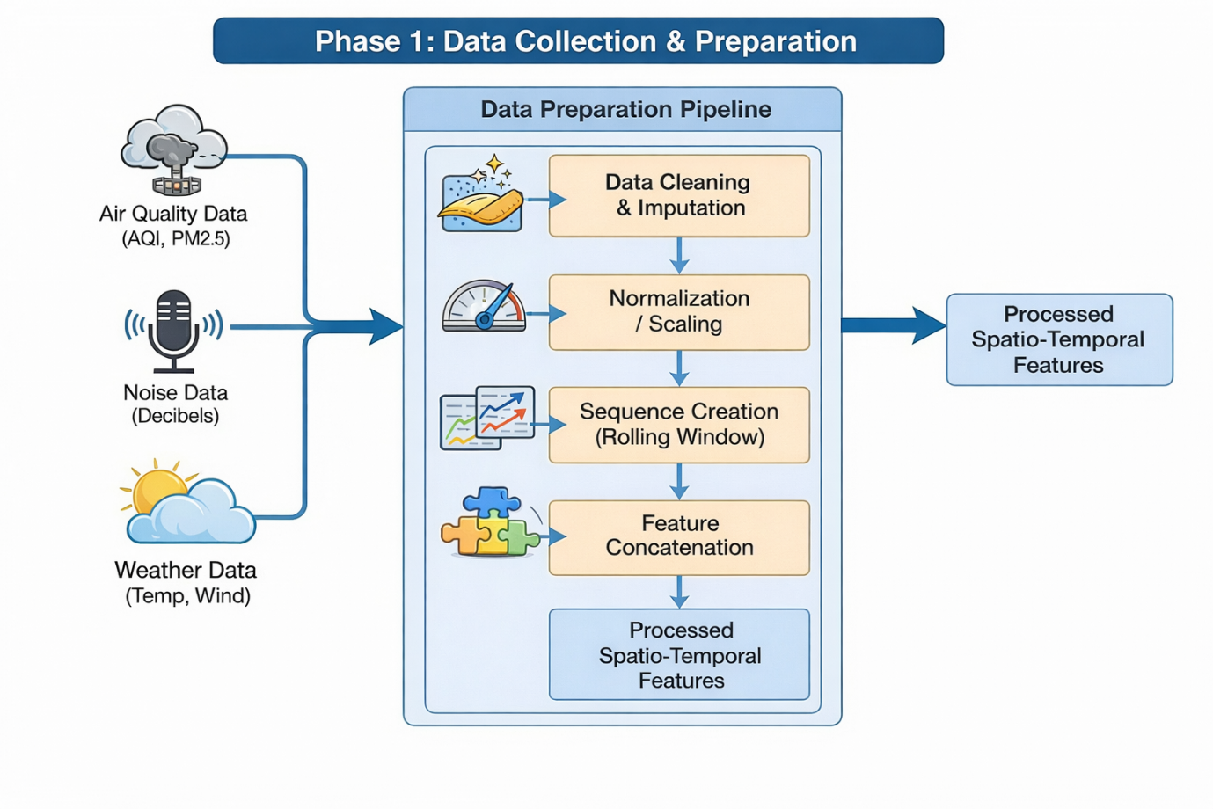
Figure 2: Air and Noise Data Collection and Preparation
After the completion of individual preprocessing tasks, the air quality and noise data streams are merged into a combined spatio-temporal data set by matching the records based on common temporal keys (year, month) and spatial identifiers. This results in a combined data set that can be effectively learned by sequence models. The inclusion of seasonality is done by one-hot encoding, which allows the models to learn the periodic patterns of the data directly instead of learning them implicitly due to the high periodicity of environmental exposure. To effectively model the temporal dependencies, the framework then goes on to build lag features (1-3 steps) for AQI, prominent pollutants, and day/night noise.
The framework then calculates the rolling statistics, specifically 3-month and 6-month moving averages, to model the short- and medium-term trends and improve the robustness against short-term variability. This ensures that all models from different families (linear, tree-based, CNN, and transformer models) are fed the same standardized lag-enhanced input, allowing for a controlled comparison. The exploratory analysis empirically confirms the construction choices: Figure 3 indicates that the lagged air quality variables are highly correlated with the current values, confirming the strong autocorrelation of AQI and validating the lag/rolling construction. However, day/night noise is weakly correlated with AQI and meteorology, as expected for event-driven processes, which further supports the noise variable as a risk-oriented target instead of a smoothly coupled one. Figure 4 further shows the strong alignment of the current and lagged AQI values and the strong presence of the seasonal pattern. Figure. 5 points out the strong presence of extreme AQI spikes, which are retained, indicating that the models need to be robust against non-Gaussian and extreme events instead of being overly smooth.
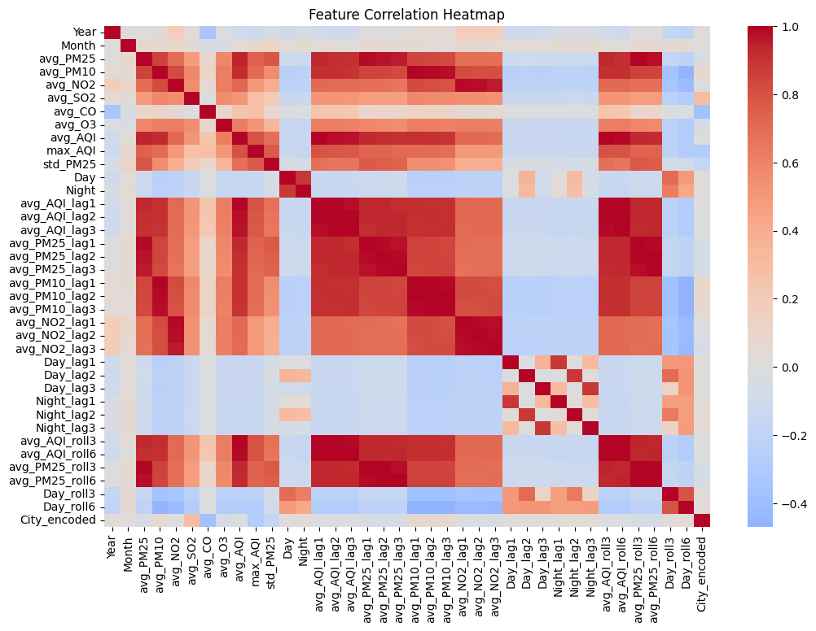
Figure 3. Feature Correlation Heatmap
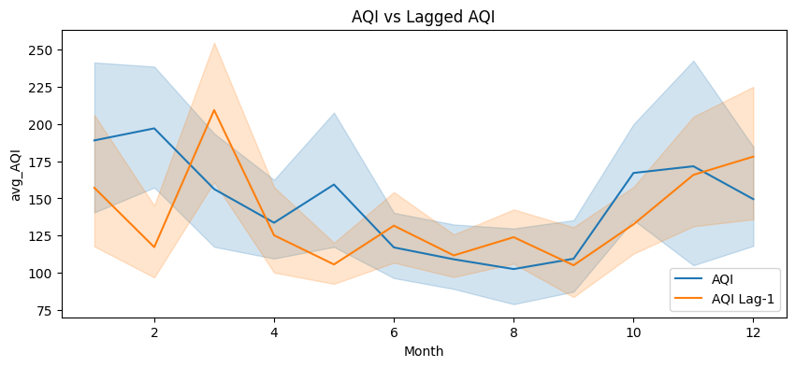
Figure 4: AQI vs Lagged AQI
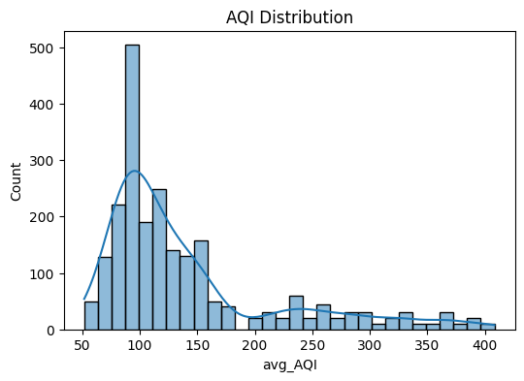
Figure 5: AQI distribution
  - Phase 2: Model Comparison and Best-Model Selection
In Phase-2 (Model Comparison & Selection), the integrated processed spatio-temporal feature sequences, including air quality variables like AQI/PM, noise indicators, and meteorological variables, are fed into three families of transformers for controlled comparison. The transformers used are as follows: (i) a Vanilla Transformer, which learns temporal patterns using multi-head self-attention on sequence embeddings; (ii) a Hybrid Conv-Attention Transformer, which improves attention using temporal convolutions to better emphasize local pattern discovery before cross/encoder attention fusion; and (iii) a TFT-Simplified Transformer, which maintains the long-range pattern modelling capability of the transformer while integrating decision-driven gating/selection for heterogeneous covariates (Fig. 6). The two-fold objective of the study is fulfilled by using a two-task regression-classification protocol to compare all models. The performance of AQI forecasting is measured using MAE (better when lower) for continuous accuracy, while the performance of noise risk prediction is measured using AUROC (better when higher) for probabilistic discrimination and reliability on risk classification. Phase-2 selects the architecture providing the best generalization and robustness on both tasks, as per the attention-driven long-range pattern modelling capability of the transformer, based on these standardized criteria.
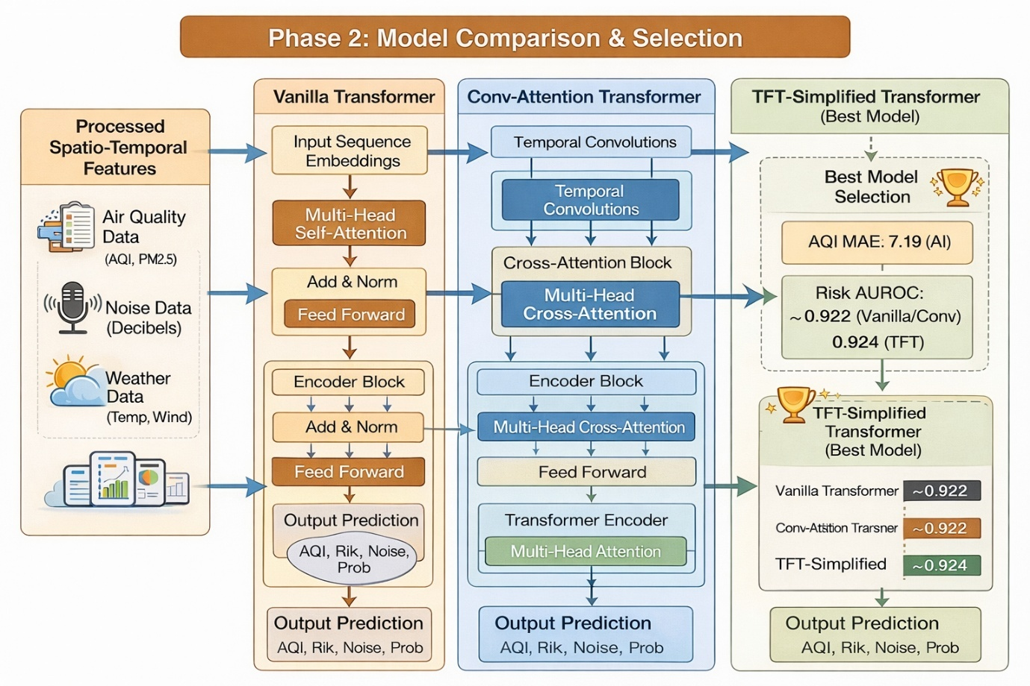
Figure 6: Model Comparison and Selection
The Vanilla Transformer is the initial candidate due to its status as the canonical attention-based sequence model. This model learns global, long-range temporal dependencies through multi-head self-attention, rendering it a principled baseline for spatio-temporal environmental forecasting in which delayed effects, seasonality, and cross-variable interactions are significant [28]. Transformer-style attention has been consistently demonstrated in the time-series literature to enhance long-sequence forecasting by more effectively capturing long-range dependency structure than exclusively local models. This is the rationale behind the adoption of a transformer backbone for AQI forecasting in our context [32], [33]. We subsequently introduce a Conv–Attention Transformer to explicitly address a known limitation of pure attention: while self-attention effectively captures global relations, environmental streams also contain local temporal motifs (short bursts, short-lived weather-driven changes, sudden pollution spikes) that are effectively extracted by temporal convolutions. Convolution-augmented transformer blocks have been demonstrated to combine local feature extraction + global context modelling in a single architecture, thereby improving representation quality in sequential data [29]. Additionally, temporal convolutional networks provide strong evidence that causal/dilated temporal convolutions are effective for sequence modelling due to their controllable receptive fields and stable training behaviour [30]. Therefore, the vanilla transformer serves as the global-attention reference point, while the conv–attention variant investigates whether the robustness of mixed urban signals is enhanced by the injection of explicit local inductive bias.
The TFT-Simplified Transformer is chosen as the core model due to the fact that the issue is not merely "long sequence forecasting," but also heterogeneous multi-source forecasting. The inputs in this case include pollutant variables, meteorology, spatio-temporal identifiers, and noise indicators, which are of varying relevance throughout time and context. The explicit proposal of TFT for interpretable multi-horizon time-series forecasting, which includes variable selection and gating mechanisms that suppress unhelpful covariates and highlight dominant drivers, while utilising interpretable attention for long-range effects, precisely aligns with our requirement to combine air, noise, and weather under a single model without allowing weakly informative signals to destabilise learning [31]. This is particularly crucial for noise, which is frequently more event-driven; TFT's gating/selection mechanism helps to concentrate on informative patterns while restricting the propagation of noise into the shared representation [31]. In conclusion, the evaluation criteria are selected to be decision-aligned. MAE is employed for AQI regression because it directly measures average absolute deviation and is widely argued to be a robust indicator of average predictive error [35]. AUROC is employed for noise-risk classification because ROC analysis is a standard, threshold-independent measure of probabilistic discrimination quality and is widely recommended for comparing classifiers under varying decision thresholds [34], [36]. Together, these three models constitute a logically stratified comparison: global attention baseline (Vanilla), local+global hybrid (Conv–Attention), and heterogeneous covariate-aware forecasting (TFT). The metrics employed in this comparison accurately reflect the dual forecasting and risk classification objectives.
  - Phase 3 :Operational System Interpretation, Alerts, and Recommendations
The last deployed TFT-Simplified Transformer in Phase-3 (Operational System: Interpretation & Alerts) is a multi-task spatio-temporal predictor, which has separate output heads for (i) AQI regression, and (ii) categorical noise-risk classification (day and night). This allows each target to be optimized and assessed based on its specific task and loss function. The predictor has a shared representation for time. The rationale for multi-task learning is that it has been noted that the shared representation developed through collaborative learning of related tasks can improve generalization and robustness compared to single-task learning alone. However, task-specific behavior is maintained through separate heads and metrics [37], [38]. The outputs of the model can be directly employed in urban intelligence systems because of this design. Noise is modeled as a probability-based risk category that better captures its event-driven characteristics, while AQI is modeled as a continuous prediction for exposure estimation (Figure. 7).
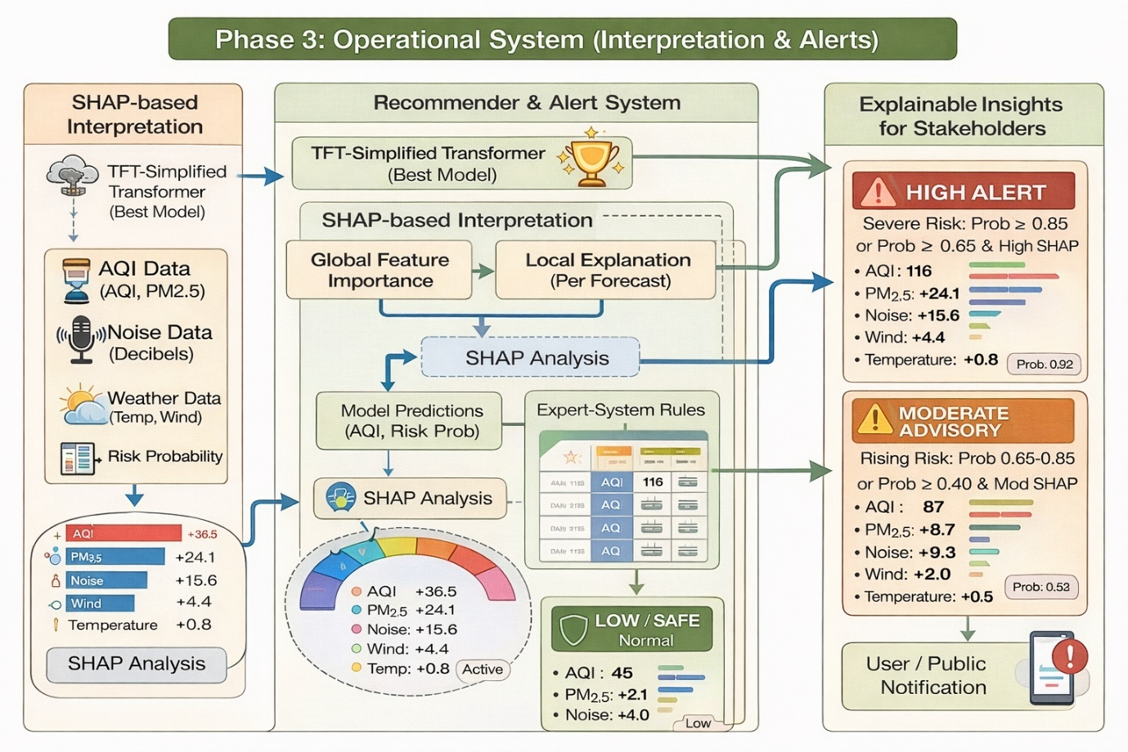
Figure 7: Operational System-Recommender and Alert Systems with XAI
In order to prevent the system from becoming a "black box," Phase 3 entails the integration of the rule-based advisory component with SHAP-based explainability (Fig. 7). SHAP enables the evaluation of the rationale behind a specific alert and the variables that guided the risk assessment by allowing for global feature importance (which variables are most influential in influencing the predictions) and local explanations [39]. The decision logic is rendered transparent and reproducible, thereby enhancing user trust, governance, and interpretability. This is consistent with the conventional rule-based expert system decision support [40]. These explanation outputs are subsequently combined with an expert rule recommender that transforms the model's predicted AQI values and noise risk probabilities into graded results (High Alert/Moderate Advisory/Low-Safe) based on explicit thresholds and conditions.
  - Flow Diagram
The holistic system flow diagram in Figure 8 consists of a unified decision-grade pipeline that combines diverse urban exposure signals. Phase-1 takes in air quality data (AQI/pollutants), day/night noise levels, and weather feeds, followed by cleaning, imputation, outlier treatment, normalization, and monthly alignment. The combined table is then augmented with one-hot encodings of seasonality, rolling window sequences, lag variables (t-1 to t-3), and 3/6-month moving averages to produce standardized spatio-temporal inputs. Phase-2 assesses regression performance on AQI MAE and probabilistic separation on noise-risk AUROC scores to compare the performance of three attention-enabled sequence learning models: Vanilla Transformer (modeling global temporal patterns), Conv-Attention Transformer (identifying local temporal patterns using global attention), and TFT-Simplified (gated variable selection with temporal attention for heterogeneous variables). The model with the highest stability (usually TFT-Simplified) is chosen for deployment. Phase-3 deploys the selected model by incorporating SHAP global/local explanations for interpretability and developing an explicit rule-based recommender system that translates predicted AQI and day/night noise-risk probabilities into tiered alerts (High/Moderate/Low) and stakeholder-friendly notifications. This approach ensures that the output is both predictive and interpretable and, importantly, actionable.
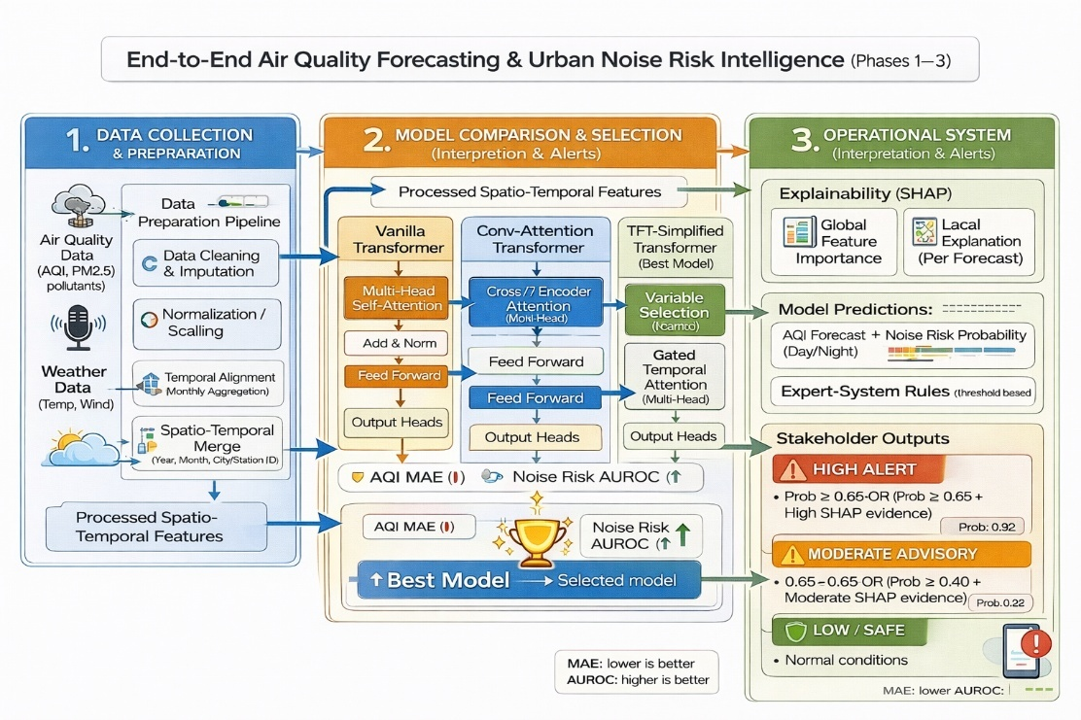
Figure 8: The holistic system flow diagram
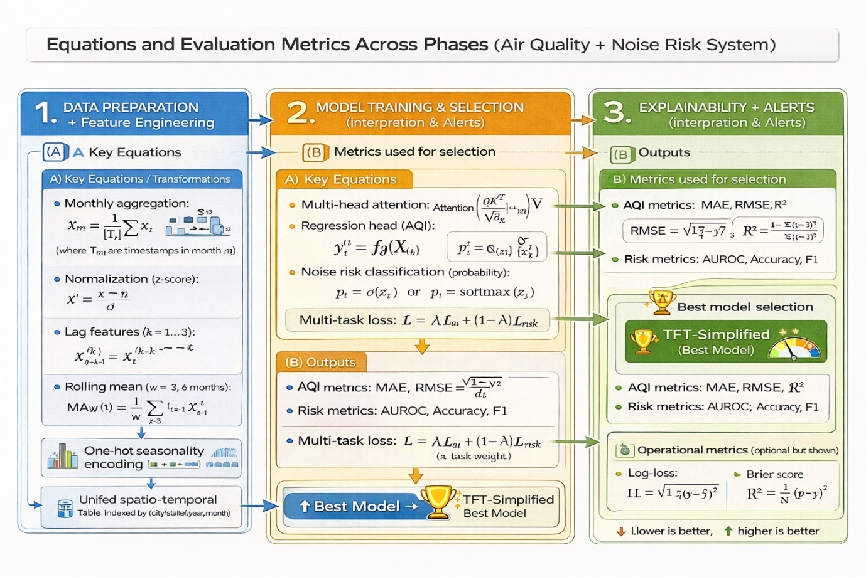
Figure 9: All phases Mathematical Equations
The proposed system is conceptualised as a phase-by-phase “math-and-evaluation map” in Fig. 9, connecting each step of the pipeline to the mathematical operations performed and the evidence produced for selection and deployment. Phase 1 is conceptualised as the transformation layer that integrates disparate air, noise, and weather data into a single spatio-temporal learning matrix. This is achieved by imposing a common temporal resolution and by modelling seasonality and temporal context, thus ensuring that the models are provided with sequence-ready data rather than isolated instances. The figure conceptualises Phase 2 as the learning-and-selection layer, where the core process is attention-driven sequence modelling, with the pipeline enabling joint continuous AQI forecasting and probabilistic noise-risk prediction. The figure also highlights that model selection is subject to a consistent evaluation protocol, ensuring that the selection of the “best model” is based on equivalent evidence for competing architectures. Phase 3 is conceptualised as the operationalisation layer, where the system is made decision-support ready by the inclusion of policy logic and explanation modules in the predictions. These modules offer stakeholder-friendly explanations at both population and individual forecast levels, with an explicit rule engine translating predictions into tiered advisories amenable to public announcement. In short, Fig. 9 illustrates the traceability of the methodology from data harmonisation to model selection based on a common evaluation framework, to interpretable and actionable deployment. This setup allows for auditing each alert to its respective input context and the evidence gathered.
  - Experimental Setup and Hyperparameters
The experimental execution plan used in this research is shown in Figure 10. Duties are distributed between a local workstation (HP i7, 16 GB RAM) and a cloud training platform (Google Colab High-RAM with an NVIDIA A100 GPU), with a unified and consistent hyperparameter protocol throughout the models. The local machine is responsible for data import, cleaning, monthly synchronization, spatio-temporal feature construction (lags and rolling statistics), and CPU-friendly baselines of the dataset. The completed spatio-temporal feature matrix and allocations are then relayed to Colab for fast deep-model training.
The cloud infrastructure supports transformer-family model training (Vanilla Transformer, Conv-Attention Transformer, and the chosen TFT-Simplified) with a unified configuration, including a time-indexed 70/15/15 split, 12-month lookback period, mixed-precision training, AdamW optimizer, early stopping with checkpointing, and consistent model size (e.g., d_model/heads/layers) and regularization. This ensures that any observed differences in performance are due to modeling power rather than varying training conditions. The final results of deployment (best weights, logs/plots, predictions, and explainability results) are also unified in the figure to ensure that the pipeline is both computationally tractable (CPU vs. GPU distinction) and experimentally reproducible (single configuration captured throughout).
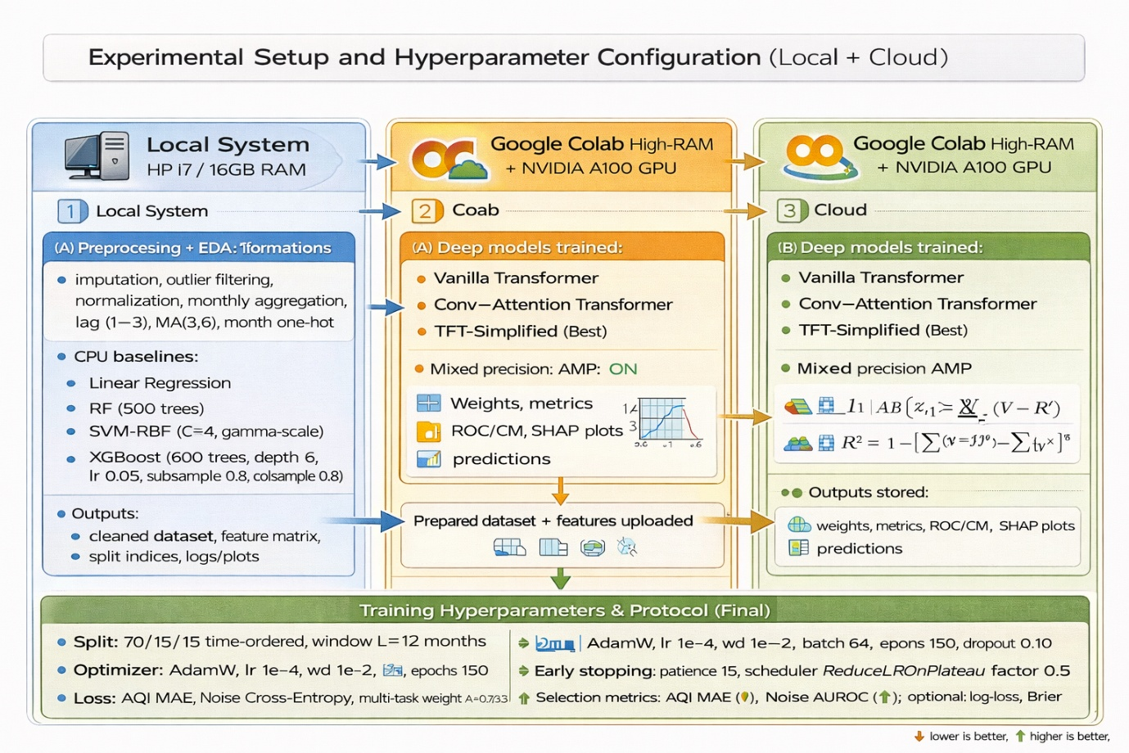
Figure 10: Experimental Setup and Hyperparameters
  - Problem Formulation
In this work, the urban environmental monitoring task is posed as a single, multi-task spatio-temporal learning problem that simultaneously tackles two very different pollution patterns in a single pipeline. The first step involves building a single lag-constructed dataset by combining air quality variables (pollutants and AQI), meteorological information, day/night noise data, and spatio-temporal features into a single, unified time-ordered representation. From this common ground, the model simultaneously generates two task-specific predictions: AQI is modelled as a continuous prediction task because of its persistence and gradual change over time, making regression a natural fit for predicting the next AQI value. Urban noise is modelled as a categorical risk classification task because of its event-driven nature at a monthly scale, lack of strong temporal autocorrelation, and poor performance in regression tasks. As such, noise is predicted as low/moderate/high risk categories for both day and night periods, with probabilistic outputs that enable confidence-aware decision-making. This formulation is conceptually captured in Figure 11, which shows a single input stream to a shared spatio-temporal learner that diverges into two distinct heads, one for AQI prediction and another for noise risk classification.
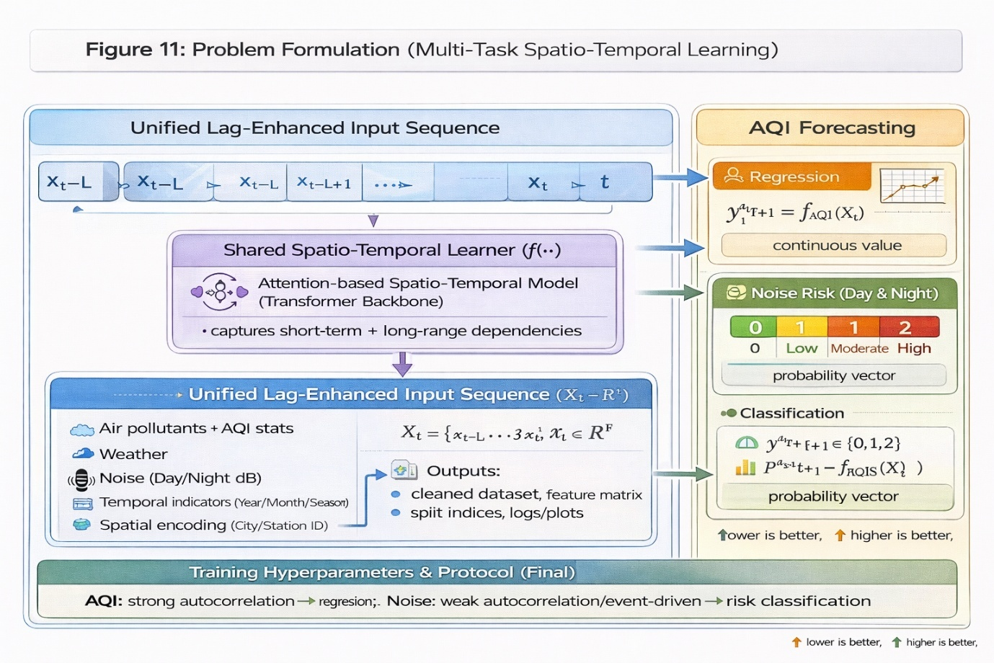
Figure 11: Problem formulation
- RESULTS
  - Results Overview
In the Results and Comparative Analysis section, we have a structured, deployment-focused evaluation pipeline. We start by determining the baseline behavior using classical/statistical and non-linear models (linear regression, XGBoost) together with a sequence-aware CNN to determine the degree of predictability that can be achieved from the lag-enhanced dataset. We then add attention mechanisms, noting that AQI forecasting is persistently unreliable under low monthly autocorrelation and event-driven variability, and noise regression is also unreliable. A unified metric set is used to compare all models to ensure a fair comparison. AQI forecasting is compared using explanatory and error-centric metrics (such as R², adjusted R², explained variance, and maximum error), while noise is considered a categorical risk classification problem and compared using accuracy metrics together with imbalance-aware reliability metrics (precision, recall, F1 in macro/micro/weighted settings, Matthews correlation coefficient, Cohen’s kappa) and probability quality/discrimination metrics (log loss, Brier score, AUROC, AUC-PR), with a strong focus on high-noise recall as the most safety-critical outcome. The main contribution is then validated by a controlled comparison of three transformer models (basic transformer with GELU, hybrid conv-attention transformer, and TFT-Simplified). The results are summarized in detailed tables and visualized by normalized comparative plots , which together reflect regression accuracy, classification robustness, and probabilistic calibration. The hybrid conv-attention transformer shows the most robust AQI forecasting performance, while TFT-Simplified provides the most consistent improvement in noise risk discrimination and calibration under class imbalance, thus justifying its selection for the operational phase. Finally, the selected transformer is deployed with SHAP-based XAI (global and local explanations) to ensure that feature importance and per-forecast reasoning are transparent. A rule-based recommender/alerting layer converts predicted AQI and noise-risk probabilities into actionable public alerts (risk-tier alerts), thus moving from raw scores to an interpretable, decision-grade urban risk intelligence workflow that meets the practical requirements of stakeholders.
  - Baseline Model Analysis
From the comparison of the baseline and deepening in Tables 2, it is clear that there is a hierarchy of AQI forecasting and a failure mode in the monthly noise regression. Linear regression shows that AQI is a predictable variable when lag-enhanced inputs are considered, and it achieves a good fit (R² = 0.921) with a low percentage error (MAPE = 2.59), which is consistent with the temporal persistence of AQI. However, the same linear assumption does not apply to noise, as the daytime noise regression has a near-zero or negative explanatory power (R² = −0.02, MAPE = 9.45), which indicates a weak linear temporal dependence and event-driven variance. XGBoost verifies that AQI forecasting can benefit from non-linear feature interactions (pollutants + meteorology + lags), and it achieves the best AQI fit among the three models (R² = 0.953). However, it is still unable to extract meaningful signal information for noise at the monthly scale (Day R² = 0.007; Night R² = −0.02). This indicates that tree ensembles, even with strong non-linear capacity, are fundamentally constrained when the temporal dependence is weak and when a risk-based class structure is more suitable than continuous regression. CNNs improve static models by learning local temporal motifs; however, the improvements are limited and tend to saturate, and the AQI performance is comparable to linear regression (R² = 0.924). Noise is still strongly negative (Day R² = −0.096; Night R² = −0.143), which confirms that convolutional locality is still ineffective in resolving the noise signal problem at the coarse temporal resolution. The empirical motivation for transforming the noise signal problem into a risk classification problem and for switching to attention-based transformers for sequence modeling and robust decision-making outputs is given in Figure 12 (bar chart comparison), which should display two prominent patterns: (i) high AQI R² values for all models with a peak at XGBoost, and (ii) near-zero or negative R² values for both day and night noise for all three models.
Table 2: Unified baseline results table (AQI + Noise)
Model | AQI Forecast R² | AQI MAPE | Day Noise Forecast R² | Day Noise MAPE | Night Noise Forecast R² | Night Noise MAPE
Linear Regression | 0.921 | 2.59 | -0.02 | 9.45 | — | —
XGBoost | 0.953 | 7.08 | 0.007 | 8.62 | -0.02 | 10.47
CNN | 0.924 | 6.40 | -0.096 | 8.68 | -0.143 | 10.91

Figure 12: plot R² bars for (AQI, Day Noise, Night Noise) across the three models (grouped bars)
Table 3: Insights of the Baseline Models
Aspect / Insight | Linear Regression | XGBoost | CNN | Key takeaway (for our project)
Role in study | Statistical baseline for inherent predictability | Non-linear baseline to test feature interactions | Sequence-aware baseline to learn local temporal patterns | Establishes why transformers are needed and why noise must be reformulated
AQI predictability (R²) | High (0.921) | Highest (0.953) | High (0.924) | AQI has strong persistence; lag features already capture much of the signal
AQI error behavior (MAPE) | Lowest (2.59) | Higher (7.08) | Moderate (6.40) | Linear model benefits from smooth AQI trends; non-linear models may overreact to variability at monthly scale
Noise regression fit (Day R²) | Negative/near-zero (−0.02) | Near-zero (0.007) | Negative (−0.096) | Day noise is weakly autocorrelated and poorly learnable as regression at monthly resolution
Noise regression fit (Night R²) | — | Negative/near-zero (−0.02) | More negative (−0.143) | Night noise is even harder; stronger evidence for event-driven dynamics
Noise error level (MAPE) | Day 9.45 | Day 8.62; Night 10.47 | Day 8.68; Night 10.91 | Errors remain high across models—consistent with low explanatory power
What each model captures well | Short-term persistence via lags | Non-linear cross-variable interactions | Local temporal motifs via convolution | None can reliably model noise as continuous regression at this temporal granularity
Main limitation observed | Too rigid (linear assumptions) | No true long-range temporal modeling; regression mismatch for noise | Limited receptive field; locality bias; still regression mismatch | The bottleneck is problem formulation for noise + need for long-range attention
Decision implication | Use only as AQI baseline | Strong AQI baseline; still insufficient for unified system | Helps confirm sequence benefit but not enough | Move to transformers for long-range modeling and noise risk classification rather than regression
Evidence supporting reformulation | Noise R² collapses | Noise R² remains ~0 | Noise R² becomes more negative | Empirically justifies converting noise prediction into Low/Moderate/High risk classification and focusing on AUROC/F1 instead of regression R²
The study's transition to transformers is also elucidated in Table 3. Despite the fact that XGBoost is capable of capturing static non-linear relationships and achieving a strong AQI fit (R² = 0.953), its near-zero/negative noise regression performance (Day R² = 0.007; Night R² = −0.02) suggests that the remaining challenge is not "more non-linearity," but temporal structure and heterogeneity. AQI is reliant on both short-term persistence and longer-range seasonal/context interactions, while noise is event-driven and weakly autocorrelated at monthly resolution. Transformers are therefore justified because attention mechanisms are specifically engineered to learn long-range dependencies and dynamic cross-variable interactions over sequences. This enables the model to (i) maintain the AQI forecasting strength beyond local lags and (ii) support a more decision-aligned formulation for noise (risk classification with probabilistic outputs) within a unified spatio-temporal framework, which tree-based models are unable to realistically represent.
  - Transformer Models Analysis
The comparison among the three transformers, as shown in Table 4 and Table 5, indicates a strongly task-dependent classification based on the relative importance of each criterion, rather than a combined ranking. For the case of AQI regression forecasting, favorable results are reflected by smaller values of MAE, MSE, RMSE, RMSLE, MAPE, SMAPE, and Max Error, and larger values of R², Adjusted R², and Explained Variance. Based on these criteria, the Convolution-augmented Attention Transformer is found to be the best overall AQI forecaster. More specifically, this model has the highest R² value (0.90696) and Explained Variance (0.90697) simultaneously, and the lowest MSE (249.14), RMSE (15.78), RMSLE (0.1242), and Max Error (141.72). This is a clear indication of a good compromise between the minimization of both average and maximum errors. The Vanilla Transformer comes second, with R² = 0.90057 and RMSE = 16.32, which shows that the attention mechanism is of great benefit, as well as the addition of the convolutional component.The trade-off is evident from the fact that TFT-Simplified has a worse regression accuracy (R² = 0.85067, RMSE = 19.996, Max Error = 162.04). This is due to TFT’s focus on gated variable selection and multi-source stability, rather than raw regression accuracy.
The accuracy of the "headline" score for the classification of daytime noise risk is comparable for Conv-Attention and TFT (0.54853) and slightly lower for the Vanilla model (0.52822). However, accuracy is not sufficient for class imbalance, and it is necessary to provide macro precision, macro recall, macro F1, MCC, Cohen's kappa, and log loss. The trend of results shows that the Vanilla Transformer has the most positive macro-level performance among the three models (Day F1_macro 0.3007, Day Recall_macro 0.3220) and the least negative agreement measures (Day MCC -0.0359, Kappa -0.0322), which indicate relatively less bias towards the majority class. Conversely, the macro precision/F1 of Conv-Attention and TFT are lower (e.g., Conv Day F1_macro 0.2579, TFT 0.2494), and the MCC/Kappa values are more negative, which indicate greater difficulty in correctly classifying the minority noise classes despite similar accuracy. The log loss is also minimized for Vanilla (0.8215) compared to Conv (0.8289) and TFT (0.8566), which indicates better quality of probability predictions for daytime risk under the present class distribution.
For nighttime noise risk, the set of metrics becomes: all three models have high Night Accuracy (around 0.82-0.84) and high micro-F1 (due to the majority class in micro-averaging). Thus, the distinguishing features are MCC/Kappa, AUC-ROC/AUC-PR, Brier, and log-loss. The most informative separation signal in the table is that the Conv-Attention Transformer has the best discrimination metrics (Night AUC-ROC = 0.6282, Night AUC-PR = 0.3800) and also the best probability discrimination and calibration among the three (lowest Night Brier = 0.09003, lowest Night Log-Loss = 0.47144), which is a sign of better ranking of night-risk probabilities. TFT-Simplified has the best agreement/accuracy metrics at night (Night MCC = 0.0150, Night Kappa = 0.0071) and the best Night Accuracy (0.83973) and weighted F1 (0.77676), but with lower AUC metrics and slightly worse calibration (Brier = 0.09310). This exactly highlights the role of Figure 13 (the comparative transformer figure): it should graphically represent Conv-Attention as the best in AQI regression metrics, while TFT/Conv swap positions depending on whether “agreement/accuracy” or “probability discrimination/calibration” is prioritized in noise risk application.
Table 4. Unified overall comparison of transformer models (key metrics)
Metric | Vanilla Transformer | Conv–Attention Transformer | TFT-Simplified
AQI MAE ↓ | 8.5587 | 8.7098 | 9.9768
AQI RMSE ↓ | 16.3170 | 15.7841 | 19.9963
AQI MAPE ↓ | 8.5232 | 8.7019 | 9.8297
AQI R² ↑ | 0.9006 | 0.9070 | 0.8507
AQI Explained Var ↑ | 0.9010 | 0.9070 | 0.8509
Day Accuracy ↑ | 0.5282 | 0.5485 | 0.5485
Day F1_macro ↑ | 0.3007 | 0.2579 | 0.2494
Day MCC ↑ | -0.0359 | -0.0826 | -0.0990
Day LogLoss ↓ | 0.8215 | 0.8289 | 0.8566
Night Accuracy ↑ | 0.8284 | 0.8217 | 0.8397
Night AUC-ROC ↑ | 0.5626 | 0.6282 | 0.5190
Night AUC-PR ↑ | 0.3625 | 0.3800 | 0.3318
Night MCC ↑ | -0.0558 | -0.0346 | 0.0150
Night LogLoss ↓ | 0.4723 | 0.4714 | 0.4877
Night Brier ↓ | 0.09056 | 0.09003 | 0.09310
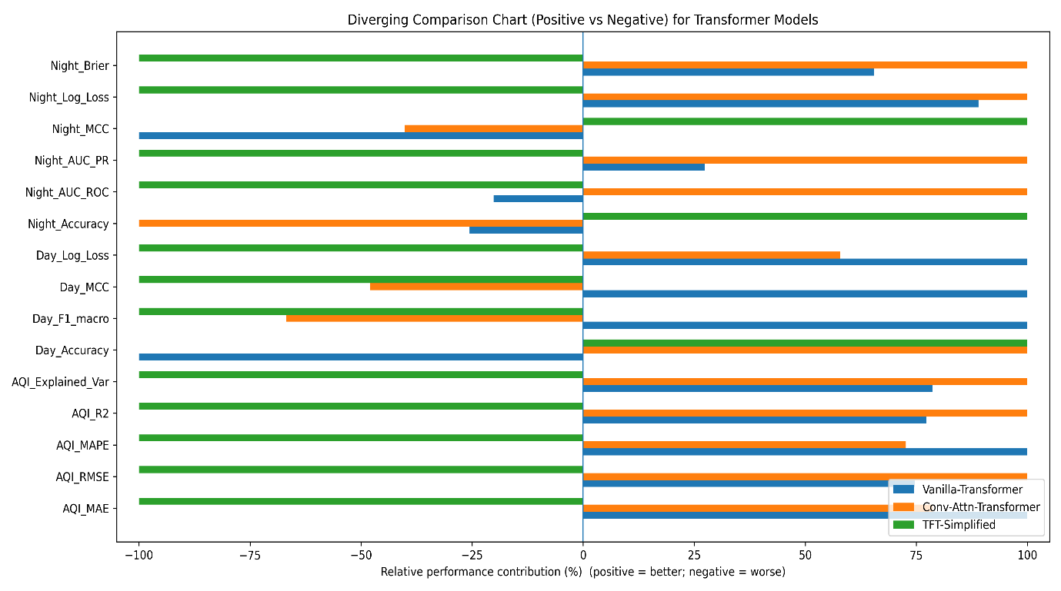
Figure 13: comparison for Transformer Models

Table 5. Detailed insights and “best model by objective”
Objective | What matters most (your reported metrics) | Best model (from your values) | Evidence (numbers) | Practical implication
AQI forecasting quality | High R²/ExplainedVar + low RMSE/MSE + low Max Error | Conv–Attention Transformer | R² 0.90696, ExpVar 0.90697, RMSE 15.78, MSE 249.14, MaxError 141.72 | Best for accurate AQI prediction and robustness to spikes; strongest “forecasting” choice
Daytime noise risk (imbalance-aware) | Macro-F1/Recall + LogLoss + MCC/Kappa | Vanilla Transformer (relative best) | Day F1_macro 0.3007 (highest), Recall_macro 0.3220 (highest), LogLoss 0.8215 (lowest), MCC −0.0359 (least negative) | Most balanced daytime risk behaviour under imbalance; still indicates need for imbalance handling
Nighttime noise probability discrimination | AUC-ROC, AUC-PR + calibration (Brier/LogLoss) | Conv–Attention Transformer | AUC-ROC 0.6282, AUC-PR 0.3800, Brier 0.09003, LogLoss 0.4714 | Best if you want reliable probability ranking and better-calibrated night alerts
Nighttime agreement-style performance | Accuracy + weighted F1 + MCC/Kappa | TFT-Simplified | Accuracy 0.8397 (highest), F1_weighted 0.7768 (highest), MCC 0.0150 (highest), Kappa 0.0071 (highest) | Best if you prioritize stable class decision agreement; useful for rule-based alerting
Best deployment trade-off | Interpretability + stable risk output + decision support | TFT-Simplified (operational choice) | Gated variable selection + competitive noise metrics; used with SHAP + recommender | Justifies selecting TFT for explainability + alert pipeline even if AQI regression is slightly lower
The study finds that TFT-Simplified is the best model for the end-to-end operational task, as shown in Table 5. This is because the ultimate system requires risk-reliable, decision-grade predictions (noise-risk alerting with explainability) rather than accurate AQI regression alone. The TFT-Simplified model reaches the best balance for the combined task with more stable night-risk classification performance, as indicated by the highest night accuracy, only positive night MCC, highest night Cohen’s kappa, and best night weighted F1. This suggests that the predicted night-risk class labels are more consistently aligned with the ground truth beyond majority-class dominance. The Conv–Attention Transformer has the best AQI forecasting capability (highest R²/explained variance and smallest error magnitudes such as RMSE and max error). Moreover, as shown in Table 5, TFT has competitive daytime accuracy (tied with Conv-Attention) and compatible architecture (gated/variable selection) for the next SHAP + rule-based recommender step, where risk probabilities with calibrated confidence are critical for tiered public alerts. Therefore, as shown in Table 5, there is a task-aware selection reason: Conv-Attention is best for AQI regression alone, and TFT-Simplified is the most robust overall choice for the combined AQI forecasting and noise-risk classification task pipeline with explainable alerting.
The self-attention weights learned by the TFT-Simplified model on the lagged monthly input sequence are shown in Figure 14. Each row (query timestep) represents how strongly the model pays attention to different past timesteps (keys) in order to produce its prediction. The model strongly favors a small set of informative delays, including those located around the central lag positions, and gives less weight to less informative timesteps. The more important areas are shown by the map.. This pattern confirms that the TFT-Simplified architecture is not treating all history equally; rather, it applies selective temporal focusing to capture the most predictive portions of the spatio-temporal context. This is advantageous for urban environmental signals, where AQI exhibits persistence but noise-related effects can be intermittent and uneven across time.
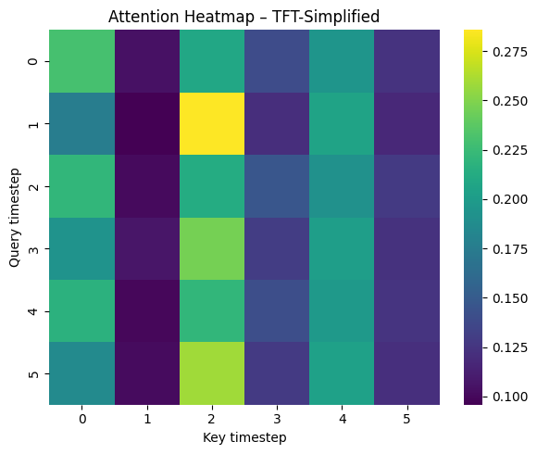
Figure 14: TFT-Simplified Model Attention Heatmap
    - Analysis of TFT-Simplified AQI Performance
Figure 15 provides conclusive diagnostic validation that the TFT-Simplified model represents the correct core engine for the integrated AQI-noise decision support system. While the choice of TFT-Simplified was primarily driven by its best-in-class reliability for night noise risk assessment—the critical operational constraint—the diagnostic results confirm that the fidelity of AQI forecasting regression performance remains unaffected, a known problem area in multi-task models where classification tasks can degrade regression accuracy. The trajectory plot (Fig. 15e) shows strong temporal correspondence with ground truth, correctly capturing sudden seasonal step-changes (e.g., at t ≈ 125) and transient volatility spikes with little lag, reflecting strong responsiveness to nonstationarity. This is further quantified by the scatter plot (Fig. 15f), where the predictions lie very close to the identity line over the entire AQI range (R² ≈ 0.9), reflecting high-quality regression performance rather than simple trend-tracking. Most importantly, the residual analysis (Fig. 15b-c) indicates that the error distribution is centered very close to zero and lacks any systematic patterns, providing conclusive evidence that there is no systematic bias (no persistent over- or under-prediction) and thereby providing strong support for decision-grade robustness. Taken together, Figure 15 illustrates that the TFT-Simplified model successfully exploits the combined lag/rolling and seasonality inputs to meet the system's two-fold operational needs: accurate continuous regression performance of AQI and reliable decision-support alerting for noise risk, thereby validating its use as the integrated model for public risk communication.
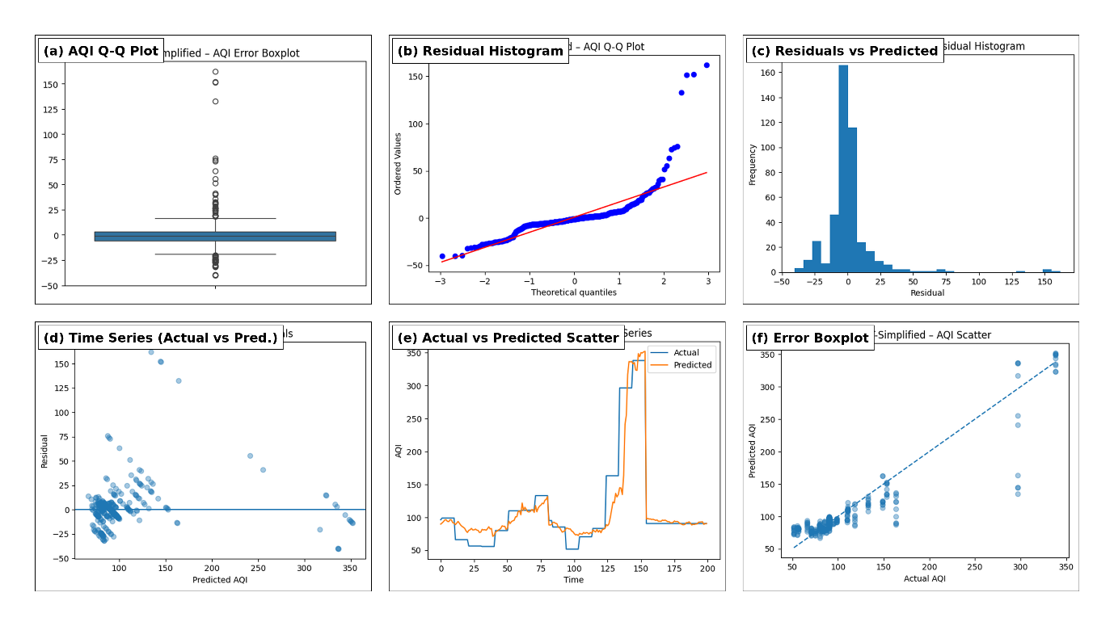
Figure 15: AQI Plots for TFI-Simplified Model
    - Classification Dynamics and Operational Safety of Day-Time Noise Risk
The TFT-Simplified strategy’s performance on the Day Noise risk classification problem can be viewed as a targeted, safety-oriented strategy, as illustrated in Figure 16. This diagnostic analysis is more demanding than that of the classifier. The confusion matrix (Figure 16c) shows that the model is extremely vigilant about the most severe consequence, which is high risk, and has correctly predicted 239 out of 259 high-risk instances (very high recall). This observation corresponds to the precision-recall curves (Figure 16a), which clearly illustrate that the high-risk path dominates the medium and low levels. At the same time, the figure also explains the nature of the difficulties involved in day noise: The ROC curves (Figure 16b) are close to the diagonal, indicating that the medium and high distributions are overlapping during active urban periods. This leads to a high transfer of medium instances to high (for example, 165 medium → high), which is marked by high-risk prediction bias. It is worth mentioning that the calibration plot (Figure 16d) displays probability oscillations, indicating that the alarm thresholds need to be tuned (and preferably calibrated) before use. However, this does not undermine the practical functionality of the system. The model’s conservative bias to mark uncertain daytime instances as “High Alert” is a safeguard in public warning systems, where the asymmetry of the consequence is critical. Despite the stochasticity and overlap involved in the class of daytime urban noise, TFT-Simplified is a sound and practical foundation for the recommender. Moreover, the cost of a false negative (missed high-risk instance) is much higher than a false positive.
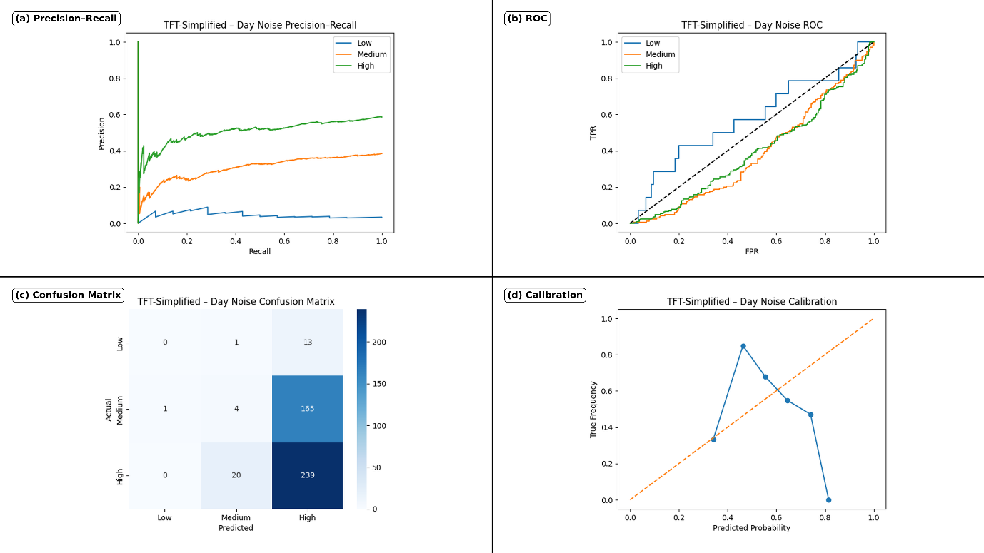
Figure 16: Night Noise Plots for TFI-Simplified Model
    - Operational Reliability of Night-Time Noise Risk Assessment
Figure 17 offers the best empirical support for using TFT-Simplified as the night risk alert engine in the integrated decision support system. This is because of its strategy for handling a detection pattern that is conservative and safe for the most serious consequence: high noise risk. The confusion matrix (Fig. 17c) shows almost perfect sensitivity, with 371 out of 375 cases correctly classified. Cases of high risk, which relate to acute nocturnal noise, are very unlikely to be missed by the system. As indicated by the precision-recall curves (Fig. 17a), the High-risk pattern remains dominant, with the lower levels (Low/Medium) often being included in High-risk predictions. This is because of both the class imbalance and the natural overlap of night conditions, which have limited separability and are evident in the ROC curves (Fig. 17b). Practically speaking, this trade-off is preferable during night hours, since the annoyance of too many warnings far exceeds the cost of a false negative (failure to warn of sleep-disrupting noise). Thus, the cautious raising of uncertain predictions is preferable for public safety. Finally, the calibration plot (Fig. 17d) suggests that high-confidence predictions are significant. The rate of observed events is reasonably well-aligned when the model makes higher probability predictions (about 0.6-1.0), offering a sound basis for automated High Alert decisions and justifying the choice of TFT-Simplified for night risk reliability.
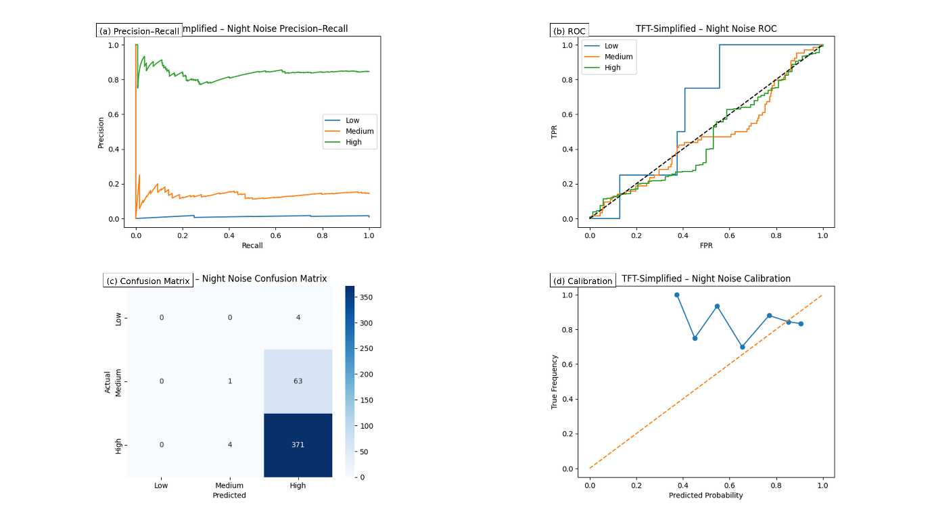
Table 6. Unified Diagnostic Insights Across AQI Forecasting (Fig. 15), Day Noise Risk (Fig. 16), and Night Noise Risk (Fig. 17).
# | Unified Insight (AQI + Day Noise + Night Noise) | AQI Forecasting Diagnostics (Fig. 15) | Day Noise Risk Diagnostics (Fig. 16) | Night Noise Risk Diagnostics (Fig. 17) | Deployment / Recommender Implication
1 | TFT-Simplified is validated as the unified core engine | (R²approx 0.9); tight scatter + accurate trajectory tracking | Safety-first behavior under daytime uncertainty | Near-total High-risk recall (371/375) supports selection | Use TFT-Simplified as the single deployment backbone for AQI + noise alerts.
2 | High temporal responsiveness where forecasting is critical | Captures abrupt step-changes (e.g., (t \approx 125)) and volatility spikes with minimal lag | Day noise separability weak during peak urban hours | Night severe-event detection remains strong despite imbalance | Trust AQI trend tracking for advisories; rely on night alerts as the most decision-grade channel.
3 | Regression reliability is diagnostic-confirmed | Residuals are near-zero-centered; no structured bias | — | — | AQI predictions are suitable for thresholded public-health messaging without systematic skew.
4 | Risk-tier overlap drives conservative escalation (not random failure) | — | ROC near diagonal; Medium→High confusion indicates overlap | ROC constrained by imbalance; Low/Medium absorbed into High | Treat Day/Night outputs as risk-sensitive decisions, not strict tier separation.
5 | Safety-first bias is operationally preferable | AQI remains strong despite multi-tasking | High-risk recall prioritized (e.g., 239/259 High detected), with more false alarms | Near-perfect High-risk recall; conservative over-warning | Encode policy: penalize false negatives more than false positives; escalate under uncertainty.
6 | Calibration needs differ by task, guiding threshold policy | Strong regression fit supports stable AQI advisories | Probability volatility → requires threshold tuning (or calibration) | High-probability region (≈0.6–1.0) aligns reasonably | Use tuned/day thresholds; allow automatic night triggers at high confidence; combine with AQI rules.
As summarized in Table 6, the TFT-Simplified diagnostics across AQI (Fig. 15), Day Noise (Fig. 16), and Night Noise (Fig. 17) collectively support its deployment as the unified decision-support backbone.
  - SHAP based Explainability Analysis
The end-to-end interpretability pipeline of the system is shown in Figure 18, which shows how the TFT-Simplified model is converted from a high-performing predictor to a transparent decision-support system that can be trusted and relied upon.The global SHAP beeswarm in Figure 18a shows that the main driving force behind the model is avg_AQI_lag1, indicating a clear and physically valid pattern. In particular, the positive SHAP values (red points) for higher previous AQI values always result in an increased predicted risk, while the negative SHAP values (blue points) for lower previous AQI values decrease the predicted risk. The clear separation between the points shows that the model is based on autoregressive environmental structure (pollutants remaining and changing over time) rather than on spurious correlations. This provides interpretable evidence to stakeholders that the reasoning behind the forecasting is valid in the real world of pollutant dynamics.
Figure 18 shows that the architecture used to obtain the insights is valid and translates the model outputs into actionable policy intelligence, in addition to attribution. To translate the probabilistic outputs into a useful planning tool for staffing, monitoring, and public warning, the temporal risk projection calendar in Figure 18b maps the predicted confidence levels into a seasonal calendar and points out a focused high-risk period in Months 5-6 (May-June), where risk intensity repeatedly reaches its peak. Finally, the metric sensitivity heatmap in Figure 18c confirms that the seasonal alerts and explanations are obtained using the most robust backbone. The TFT-Simplified column is shown to be the most stable among Vanilla, Conv-Attention, and TFT-Simplified, achieving the highest robustness score on the most important AQI R² metric. In summary, these figures demonstrate “glass-box” transparency, explaining the reasoning behind the predictions, the timing of risk concentrations, and the reasons why the chosen architecture is trustworthy and reliable enough to be deployed.
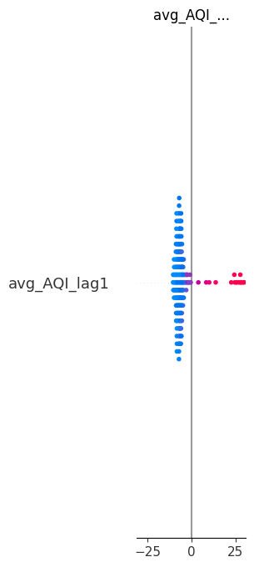
(a)
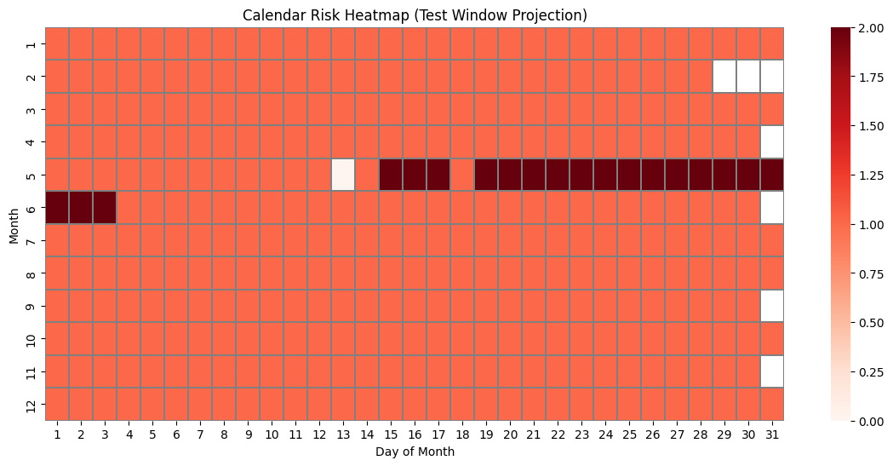
(b)
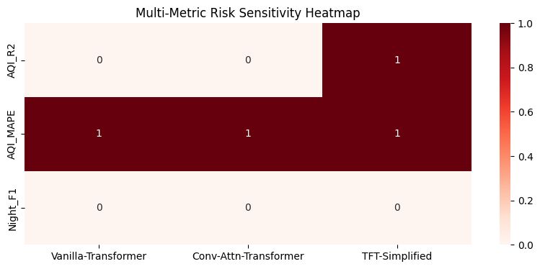
(c)
Figure 18. Multi-faceted interpretability framework for the unified system. (a) Global SHAP beeswarm highlights avg_AQI_lag1 as the dominant driver, with higher prior values increasing predicted risk. (b) Calendar heatmap projects confidence over time, revealing consistent high-risk windows in Months 5–6 for proactive planning. (c) Metric sensitivity matrix confirms TFT-Simplified as the most robust backbone (score = 1 on $R^{2}$) for producing reliable explanations and alerts.
  - Recommender System
As specified in Fig. 19 and Table 7, the last contribution of this study is the decision layer ready for deployment, which takes the multi-task model outputs and produces actionable public risk alerts that are auditable and transparent. After the TFT-Simplified model has generated (i) a forecast of the continuous AQI and (ii) probabilistic day/night noise-risk predictions, the system provides SHAP explanations for each forecast to identify the contributions of the factors (pollutants, meteorology, time, and noise indicators) that influenced the predicted risk, thus allowing both global (overall feature contribution) and local (per-instance) interpretability. These predictions and explanation signals are then fed into a rule-based recommender/alert system that translates the predicted AQI and risk probabilities into tiered alerts (e.g., High Alert, Moderate Advisory, Low/Safe), ensuring that the final output is not simply a numerical value but rather a recommendation for the user that is amenable to notification systems. Table 7 encapsulates this process logic and result reporting by listing the alert category definitions, the probability/threshold criteria for each alert category, and the explanation evidence supporting each alert, while Figure. 19 traces the complete end-to-end process from data → model inference → explanation → rule evaluation → notification.
Table 7. Rule-based Recommender and Risk Alert Notification Logic (AQI + Noise Risk + SHAP Evidence)
Alert Tier | Trigger Condition (Risk Probability + Evidence) | AQI Condition (Forecast) | Noise Condition (Day/Night Risk) | Explanation Evidence Used (SHAP) | Recommended Public Action
HIGH ALERT (Severe Risk) | (p_{risk} \ge 0.85) OR ((p_{risk} \ge 0.65) AND SHAP evidence = High() ) | AQI in Poor/Very Poor/Severe band (or sharp rise vs previous month) | Day or Night classified as High risk with high confidence | Local SHAP: top drivers show strong positive impact from AQI/PM2.5/noise + adverse weather; Global SHAP confirms consistent drivers | Immediate advisory: reduce outdoor exposure, mask/respiratory caution, avoid high-noise zones, sensitive groups stay indoors
MODERATE ADVISORY (Rising Risk) | (0.65 \le p_{risk} < 0.85) OR ((p_{risk} \ge 0.40) AND SHAP evidence = Moderate() ) | AQI in Moderate/Unhealthy for Sensitive band (or moderate upward trend) | Day or Night classified as Moderate risk or borderline High | Local SHAP: moderate positive contributions from AQI/PM2.5/noise and temporal factors (seasonality); risk not dominated by a single factor | Precautionary advisory: limit prolonged outdoor activity, monitor updates, reduce noisy activities at night, prefer quieter routes/areas
LOW / SAFE (Normal) | (p_{risk} < 0.40) OR risk predicted Low with weak SHAP evidence | AQI in Good/Satisfactory band and stable trend | Day and Night predicted Low risk | Local SHAP: small/near-zero positive impacts; drivers do not indicate escalation | Normal conditions: routine activity allowed; maintain awareness
ESCALATION / REVIEW (Uncertain or Conflicting) | Model confidence unstable OR Day and Night conflict OR SHAP evidence contradicts high probability | Any AQI band if probability/explanations disagree | Day vs Night inconsistent (e.g., Day Low but Night High) | Local SHAP shows atypical driver pattern or weak attribution despite high probability | Flag for verification: highlight uncertainty, recommend cross-check with local advisories/sensors

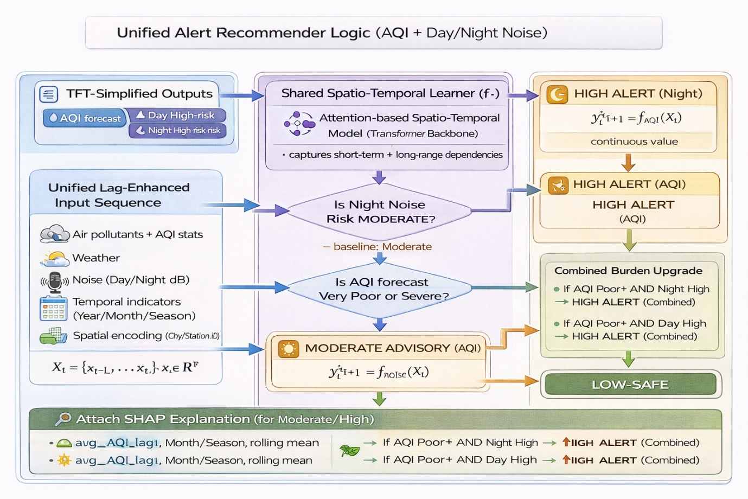
Figure 19: Unified Recommender logic for NOISE and Air Risk
- DISCUSSION
  - Overall Analysis
The experimental results provide a coherent, value-judgment-informed model fitness evaluation for the unified AQI-noise model framework and demonstrate the underlying reasons for the subpar performance of some model families despite their seemingly strong presence in the traditional air quality literature. During the baseline phase, linear regression provides a reliable AQI prediction (R² = 0.921, MAPE = 2.59) because monthly-scale AQI is largely driven by persistence and because the lag/rolling feature is designed to model short-term dependencies; in contrast, the same model is ineffectual for noise (day noise R² = -0.02, MAPE = 9.45), suggesting that monthly noise is largely unstructured in a linear temporal sense and is instead dominated by irregular events (traffic patterns, construction cycles). XGBoost improves AQI model performance (R² = 0.953) by modeling non-linear interactions between variables (pollutants, weather, and lag context), although it is again ineffectual at modeling noise dynamics (Day R² = 0.007; Night R² = -0.02, Night MAPE = 10.47), which is expected because nonlinearity alone is insufficient to address the underlying discrepancy between event-driven noise and regression learning at a coarse temporal granularity. CNN models improve sequence modeling for AQI only slightly (R² = 0.924, MAPE = 6.40) but are again ineffectual at modeling noise (Day R² = -0.096; Night R² = -0.143), as expected because convolutions are designed to identify localized patterns and lack a large receptive field; they are therefore unsuitable for modeling long-range seasonality and weakly coupled variables when the underlying signal is dominated by intermittency rather than smooth autocorrelation. These baseline results therefore justify the paradigm shift: AQI is properly learned via regression, but noise must be properly modeled as a risk classification problem and learned using architectures that are designed to reason about longer-range temporal dependencies and feature relevance.
The transformer analysis confirms that attention-based models are the right next step, and there is a strong task-dependent trade-off that helps with the final choice. For AQI regression, the Conv-Attention Transformer achieves the best fit and robustness values: AQI R² = 0.9070, Explained Variance = 0.9070, RMSE = 15.7841, and Max Error = 141.7191. This result confirms the architectural assumption that local convolution and global attention can both capture short-term variations in pollutants as well as seasonal patterns. The Vanilla Transformer is still a strong contender but slightly less so for AQI (R² = 0.9006, RMSE = 16.3170), suggesting that attention is a strong mechanism but can be improved by local convolutional feature extraction. In contrast, TFT-Simplified is slightly subpar for AQI (R² = 0.8507, RMSE = 19.9963); however, it becomes more attractive for operational risk deployment because of its better night-risk agreement behaviour. It obtains the best Night Accuracy (0.8397) and is the only model with a positive Night MCC (0.0150) and a positive Night Cohen’s kappa (0.0071), besides the best Night weighted F1 (0.7768), while also keeping the best-tied Day Accuracy (0.5485). This distribution leads to the central conclusion: Conv-Attention is the best AQI forecaster, but TFT-Simplified is the best end-to-end operational model since public alerting demands stable and confidence-consistent classification performance (particularly at night) and compatibility with interpretability results and the SHAP plus rule-based recommender layer.
The noted macro-score performance issues and negative Day MCC/Kappa for all models (despite having about 0.55 Day accuracy) further suggest that class imbalance and minority-risk rarity conditions impede risk learning during the daytime. The system’s final architecture design, therefore, properly prioritises probabilistic scoring (AUROC/AUC-PR, log-loss, Brier) and explanation-driven rules over accuracy. In summary, the values presented provide a rationale for why some models perform suboptimally (mismatched objective, short-term focus, poor noise autocorrelation) and why the chosen model is preferable (risk validity, usability, and alignment with explanations), offering a cohesive and evidence-driven explanation for the integrated environmental intelligence system.
  - Ablation Study
To identify which of these design choices have a significant influence beyond simple leaderboard rankings, we performed an ablation study and statistical significance analysis, focusing on (i) architectural choices (pure attention vs. adding convolution vs. gated/variable selection in TFT) and (ii) feature engineering choices (lags/rolling/seasonality) in the same train-test setting. The results are summarized in Table 8. The ablation study results show that the combination of convolutional local feature extraction on top of attention is the most effective in AQI regression tasks (Conv-Attention outperforms Vanilla on higher AQI R2, R2, and explained variance, and lower RMSE). On the other hand, the TFT-style gating/variable selection has a greater effect on the stability of night-risk predictions (TFT obtains the best night agreement-style metrics, including highest positive MCC/Kappa and night accuracy), as expected to confirm that the “best AQI forecaster” architecture is not necessarily the same as the “best alert-ready risk model” architecture.However, to make a proper claim of significance using a paired t-test (or Wilcoxon signed-rank test), multiple independent repeats (at least 10 random seeds or rolling-origin folds) are needed since a single test set point estimate per model is not enough to estimate the variance. Hence, the effect size (Δ) in Figure 20 is calculated from the observed values, and the exact t-test design (unit of comparison, number of repeats needed, and decision thresholds) is specified to make the significance statement reproducible once the metrics from repeat runs are recorded.
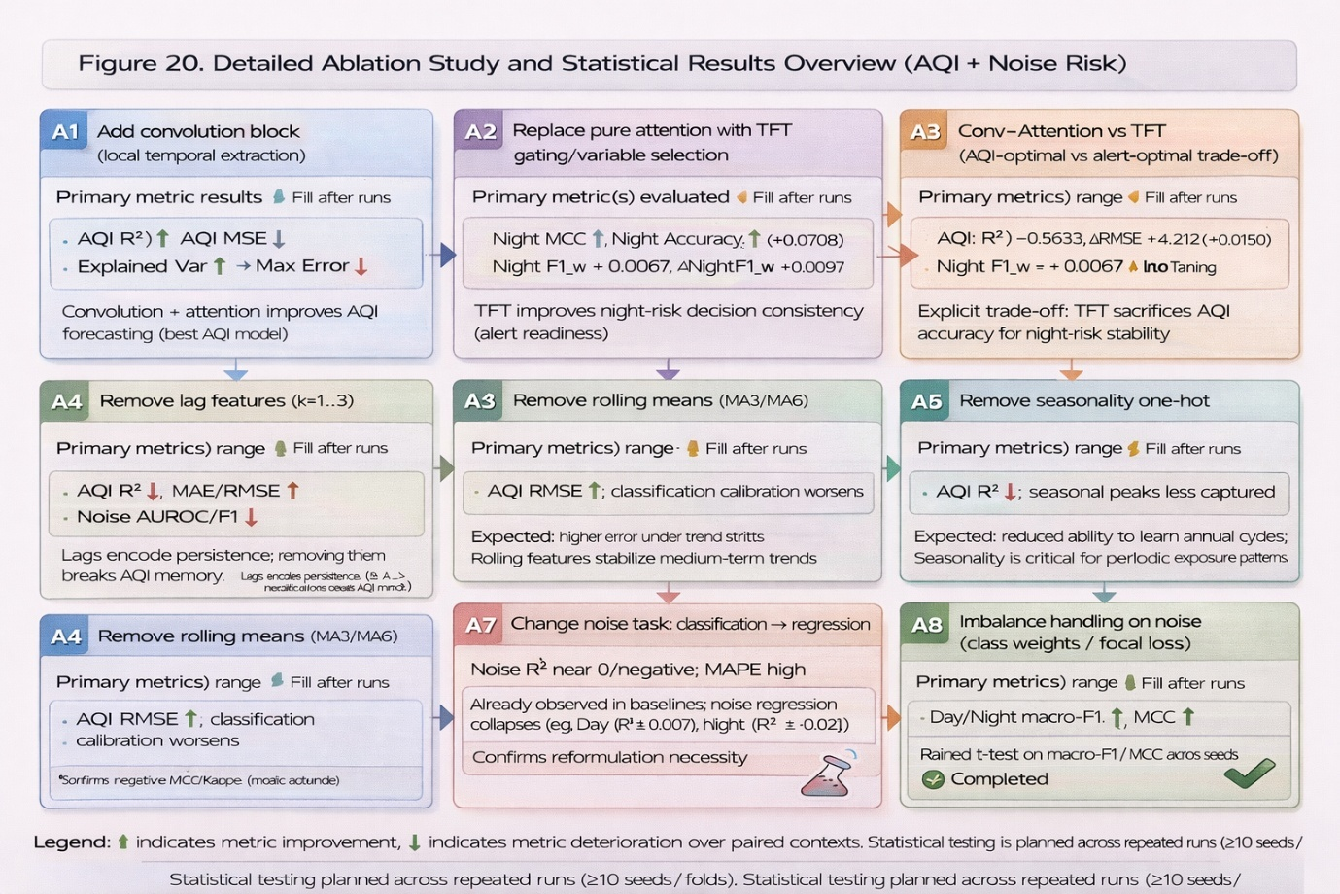
Figure 20:Ablation study and statistical t-test plan
  - Public Relevance and Global Impact
This research provides direct worldwide value by transforming environmental monitoring from simple data reporting to decision-support, explainable, public risk intelligence that can be easily applied across cities with little to no modification. By simultaneously predicting air quality (AQI) and identifying day/night environmental noise risk levels in a single spatio-temporal model, the system provides for timely public alerts of two significant, concurrent urban health hazards that impact billions of people worldwide, especially children, seniors, and those with respiratory and cardiovascular risk. In contrast to dashboard systems that display raw numbers, the proposed processing pipeline provides actionable alert levels (high, moderate, low) based on model confidence and interpretable SHAP explanations, enabling citizens, hospitals, schools, transportation agencies, and smart city operations centers to better understand the reasoning behind a given alert and take informed action (such as reducing outdoor activities, redirecting traffic, and enforcing nighttime noise regulations). As this method relies on widely accessible environmental monitoring resources and attention-based modeling that generalizes well to long-term temporal patterns, it is highly amenable to large-scale integration with public health early warning systems, urban policy enforcement, and climate resilience planning, ultimately preventing unnecessary exposure, improving quality of life, and increasing public confidence in AI-assisted environmental stewardship globally.
- CONCLUSION AND FUTURE WORK
This work proposes an end-to-end, attention-based spatio-temporal model that combines AQI forecasting and urban noise risk classification into a single processing pipeline, thus filling the existing gap where air quality and noise are generally treated as distinct problems. The experimental results show that traditional baselines perform well in AQI forecasting with high temporal persistence (e.g., linear regression R² = 0.921; XGBoost R² = 0.953), but fail to model noise as a regression problem (close to zero or negative R² for day/night), thus confirming the event-driven and weakly autocorrelated nature of monthly noise. Transformer models provide a stronger spatio-temporal learning capability; the Conv-Attention Transformer outperforms all other models in AQI regression tasks (AQI R² = 0.907, RMSE = 15.784), while the TFT-Simplified model provides the best risk alerting balance, providing the highest night-risk consistency metrics (Night Accuracy = 0.8397, positive Night MCC = 0.015, positive Night Kappa = 0.007). The best TFT-Simplified model was then applied to SHAP explainability and rule-based recommender systems, which converted multi-task predictions into interpretable, tiered public alerts. In summary, the experimental results confirm that (i) AQI should be modelled as a continuous forecasting problem, (ii) noise should be modelled as a categorical risk problem, and (iii) attention-based models enable an explainable, decision-grade environmental intelligence system.
Future research will move the AQI-noise unification framework towards greater realism and deployability by progressing from monthly aggregation to daily and hourly modeling, adding event-aware features to better model noise spikes and minority-risk cases, and validating generalization across cities by domain adaptation and continual learning. The framework will also add improved uncertainty quantification and calibration for confidence-aware alerting, expand to multi-horizon forecasting for early warning systems, add input features with proxies for pollution sources (such as traffic, industry, and fire notifications), and refactor the system into a lightweight API and dashboard with mobile alert deployment, along with stakeholder pilot studies.
Declarations
Abbreviations
• AQI: Air Quality Index
• AUC-PR: Area Under the Precision–Recall Curve
• AUROC: Area Under the Receiver Operating Characteristic Curve
• CNN: Convolutional Neural Network
• CPCB: Central Pollution Control Board
• GELU: Gaussian Error Linear Unit
• MAE: Mean Absolute Error
• MAPE: Mean Absolute Percentage Error
• MCC: Matthews Correlation Coefficient
• MSE: Mean Squared Error
• RMSE: Root Mean Squared Error
• RMSLE: Root Mean Squared Logarithmic Error
• SHAP: SHapley Additive exPlanations
• SMAPE: Symmetric Mean Absolute Percentage Error
• TFT: Temporal Fusion Transformer
• XAI: Explainable Artificial Intelligence
• XGBoost: Extreme Gradient Boosting
Ethics approval and consent to participate
This research makes use of publicly available environmental monitoring data and does not involve human subjects or private identifiable information.
Consent for publication
Not applicable.
Availability of data and materials
The datasets used in this study are publicly available:
• Air Quality Data in India (2015–2020): https://www.kaggle.com/datasets/rohanrao/air-quality-data-in-india
• Noise Monitoring Data in India (2011–2018): https://www.kaggle.com/datasets/rohanrao/noise-monitoring-data-in-india
All code, artifacts of trained models, and processed datasets (including monthly aggregates and lag/rolling feature-engineered views) will be made available upon reasonable request to the respective authors or released through an open repository.
Funding
There is no external funding for this project.
Competing interests / Conflicts of Interest
The authors declare that they have no competing interests and no conflicts of interest.
Acknowledgments
The authors would like to thank the Department of Computing Technologies, School of Computing, College of Engineering & Technology, SRM Institute of Science and Technology, Kattankulathur, for providing the computational resources and research infrastructure necessary for this work. Special thanks are given to Kampala International University, Uganda, for enabling international research collaboration and interdisciplinary perspectives. The authors would also like to thank the domain experts whose feedback has added to the practical utility of this work. Finally, we thank all individuals and institutions whose indirect contributions have helped complete this research successfully.
Authors’ contributions
• Akella S. Narasimha Raju: Conceptualization, Methodology, Model Design, Investigation, Writing – Original Draft, Supervision
• Shovik Banerjee: Data Curation, Dataset Integration, Preprocessing, Formal Analysis, Writing – Review & Editing
• Kaushani Chakraborty: Literature Survey, Experimental Validation Support, Results Interpretation, Writing – Review & Editing
• Venkataramana Guntreddi: Visualization, SHAP/XAI presentation support, Writing – Review & Editing, Final Draft Coordination
All authors read and approved the final manuscript.
Corresponding authors
Correspondence to:
• Akella S. Narasimha Raju Email: akellar@srmist.edu.in
• Venkataramana Guntreddi - Email: gvramana@kiu.ac.ug
Underlying conclusions based upon raw data
The findings of this research are supported by the raw data extracted from publicly available air quality and environmental noise measurement datasets mentioned above. The intermediate results of the experimentation process, such as the cleaned monthly aggregates, lag and rolling feature sets, trained model checkpoints, prediction results, and SHAP explanation files, can be made available upon request or shared through an open repository.
References
[1] World Health Organization, “Ambient (outdoor) air pollution,” Fact sheet, Oct. 24, 2024. [Online]. Available: https://www.who.int/news-room/fact-sheets/detail/ambient-(outdoor)-air-pollution. [Accessed: Feb. 4, 2026].
[2] Health Effects Institute, State of Global Air 2024, Special Report. Boston, MA: Health Effects Institute, 2024. [Online]. Available: https://www.stateofglobalair.org/resources/report/state-global-air-report-2024. [Accessed: Feb. 4, 2026].
[3] World Health Organization, “Nitrogen dioxide (NO₂),” Air quality and health, 2024. [Online]. Available: https://www.who.int/teams/environment-climate-change-and-health/air-quality-and-health/health-impacts/types-of-pollutants. [Accessed: Feb. 4, 2026].
[4] World Health Organization Regional Office for Europe, Biological mechanisms related to cardiovascular and metabolic effects by environmental noise. Copenhagen, Denmark: WHO Regional Office for Europe, 2018.
[5] World Health Organization Regional Office for Europe, “New WHO noise guidelines for Europe released,” News release, Oct. 10, 2018. [Online]. Available: https://www.who.int/europe/news/item/10-10-2018-new-who-noise-guidelines-for-europe-released. [Accessed: Feb. 4, 2026].
[6] D. Halperin, “Environmental noise and sleep disturbances: A threat to health?,” Sleep Sci., vol. 7, no. 4, pp. 209–212, Dec. 2014, doi: 10.1016/j.slsci.2014.11.003.
[7] X. Wang, S. Zhang, Y. Chen, et al., “Air quality forecasting using a spatiotemporal hybrid deep learning model based on VMD–GAT–BiLSTM,” Sci. Rep., vol. 14, Art. no. 17841, Aug. 2024, doi: 10.1038/s41598-024-68874-x.
[8] C. Yu, F. Wang, Y. Wang, et al., “MGSFformer: A Multi-Granularity Spatiotemporal Fusion Transformer for air quality prediction,” Inf. Fusion, vol. 113, Art. no. 102607, Jan. 2025, doi: 10.1016/j.inffus.2024.102607.
[9] P.-Y. Kow et al., “A CNN-transformer framework for air quality forecasting to support aeolian dust management in river basins,” Adv. Eng. Informat., vol. 68, Part B, Art. no. 103758, Nov. 2025, doi: 10.1016/j.aei.2025.103758.
[10] A. Vaswani et al., “Attention is all you need,” in Advances in Neural Information Processing Systems (NeurIPS), vol. 30, I. Guyon et al., Eds. Red Hook, NY: Curran Associates, Inc., 2017, pp. 5998–6008.
[11] B. Lim, S. O. Arik, N. Loeff, and T. Pfister, “Temporal Fusion Transformers for interpretable multi-horizon time series forecasting,” Int. J. Forecast., vol. 37, no. 4, pp. 1748–1764, Oct. 2021, doi: 10.1016/j.ijforecast.2021.03.012.
[12] R. Muljana et al., “Air Pollution Prediction using Random Forest Classifier: A Case Study of DKI Jakarta,” in Proc. 2023 Int. Conf. Computer Science, Information Technology and Engineering (ICCoSITE), Jakarta, Indonesia, Feb. 2023, pp. 428–434, doi: 10.1109/ICCoSITE57641.2023.10127759.
[13] K. M. O. V. K. Kekulunadara, B. T. G. S. Kumara, and B. Kuhaneswaran, “Comparative analysis of machine learning algorithms for predicting air quality index,” in Proc. 2021 Int. Conf. from Innovation to Impact (FITI), Colombo, Sri Lanka, 2021, pp. 1–6, doi: 10.1109/FITI54907.2021.9711628.
[14] H. Cheng and H. Fan, “PM2.5 Concentration Hourly Multi-Step Prediction Using Spatial-Temporal Synchronous Graph Convolution Network,” in Proc. IEEE Int. Geoscience and Remote Sensing Symp. (IGARSS), Athens, Greece, Jul. 2024, pp. 5727–5731, doi: 10.1109/IGARSS53475.2024.10640613.
[15] P. Kotlia, M. C. Lohani, and J. Pant, “Applying Machine Learning for Predictive Analysis for Air Quality Assessment across different Districts in Uttarakhand,” in Proc. 2024 First Int. Conf. Innovations in Communications, Electrical and Computer Engineering (ICICEC), Dehradun, India, Oct. 2024, pp. 1–6, doi: 10.1109/ICICEC62498.2024.10808861.
[16] Y. Liang et al., “AirFormer: Predicting Nationwide Air Quality in China with Transformers,” in Proc. AAAI Conf. Artificial Intelligence, vol. 37, no. 12, pp. 14329–14337, Jun. 2023, doi: 10.1609/aaai.v37i12.26676.
[17] R. Zhang and N. Awang, “A novel ST-iTransformer model for spatio-temporal ambient air pollution forecasting,” J. Big Data, vol. 12, Art. no. 101, Apr. 2025, doi: 10.1186/s40537-025-01150-5.
[18] Central Pollution Control Board, “National Air Quality Index (AQI),” Ministry of Environment, Forest and Climate Change, Govt. of India. [Online]. Available: https://airquality.cpcb.gov.in. [Accessed: Jan. 2026].
[19] Central Pollution Control Board, “Real time noise monitoring data,” Ministry of Environment, Forest and Climate Change, Govt. of India. [Online]. Available: https://cpcb.nic.in/noise-monitoring-data/. [Accessed: Jan. 2026].
[20] H. Zhang, “Measuring and evaluating the environmental noise in the campus of Southwest Forestry University,” in Proc. 2011 Int. Conf. Electrical and Control Engineering (ICECE), Yichang, China, Sep. 2011, pp. 2325–2328, doi: 10.1109/ICECENG.2011.6057917.
[21] J. Zhang, “The research of city road next to the construction noise analysis,” in Proc. 2010 Int. Conf. Mechanic Automation and Control Engineering (MACE), Wuhan, China, Jun. 2010, pp. 2047–2050, doi: 10.1109/MACE.2010.5536272.
[22] J. Ji, J. He, M. Lei, M. Wang, and W. Tang, “Spatio-Temporal Transformer Network for Weather Forecasting,” IEEE Trans. Big Data, vol. 11, no. 2, pp. 372–387, Apr. 2025, doi: 10.1109/TBDATA.2024.3378061.
[23] R. Rao, “Air Quality Data in India (2015–2020),” Kaggle, 2020. [Online]. Available: https://www.kaggle.com/datasets/rohanrao/air-quality-data-in-india. [Accessed: Feb. 4, 2026].
[24] R. Rao, “Noise Monitoring Data in India (2011–2018),” Kaggle, 2018. [Online]. Available: https://www.kaggle.com/datasets/rohanrao/noise-monitoring-data-in-india. [Accessed: Feb. 4, 2026].
[25] Central Pollution Control Board, “National Air Quality Index (AQI),” Ministry of Environment, Forest and Climate Change, Govt. of India. [Online]. Available: https://airquality.cpcb.gov.in. [Accessed: Jan. 2026].
[26] ENVIS Centre on Control of Pollution Water, Air and Noise, “Real Time Noise Monitoring Data,” Central Pollution Control Board, Govt. of India. [Online]. Available: https://cpcb.nic.in/noise-monitoring-data. [Accessed: Jan. 2026].
[27] Y. LeCun, L. Bottou, G. B. Orr, and K.-R. Müller, “Efficient BackProp,” in Neural Networks: Tricks of the Trade, G. B. Orr and K.-R. Müller, Eds. Berlin, Germany: Springer, 1998, pp. 9–50, doi: 10.1007/3-540-49430-8_2.
[29] A. Gulati et al., “Conformer: Convolution-augmented Transformer for speech recognition,” in Proc. Interspeech 2020, Shanghai, China, Oct. 2020, pp. 5036–5040, doi: 10.21437/Interspeech.2020-3015.
[30] S. Bai, J. Z. Kolter, and V. Koltun, “An empirical evaluation of generic convolutional and recurrent networks for sequence modeling,” arXiv preprint arXiv:1803.01271, 2018.
[31] B. Lim, S. O. Arik, N. Loeff, and T. Pfister, “Temporal Fusion Transformers for interpretable multi-horizon time series forecasting,” Int. J. Forecast., vol. 37, no. 4, pp. 1748–1764, Oct. 2021, doi: 10.1016/j.ijforecast.2021.03.012.
[32] H. Zhou et al., “Informer: Beyond efficient transformer for long sequence time-series forecasting,” in Proc. AAAI Conf. Artificial Intelligence, vol. 35, no. 12, pp. 11106–11115, May 2021, doi: 10.1609/aaai.v35i12.17325.
[33] H. Wu, J. Xu, J. Wang, and M. Long, “Autoformer: Decomposition Transformers with Auto-Correlation for long-term series forecasting,” in Advances in Neural Information Processing Systems (NeurIPS), vol. 34, M. Ranzato et al., Eds. Red Hook, NY: Curran Associates, Inc., 2021, pp. 22419–22430.
[34] T. Fawcett, “An introduction to ROC analysis,” Pattern Recognit. Lett., vol. 27, no. 8, pp. 861–874, Jun. 2006, doi: 10.1016/j.patrec.2005.10.010.
[35] C. J. Willmott and K. Matsuura, “Advantages of the mean absolute error (MAE) over the root mean square error (RMSE) in assessing average model performance,” Clim. Res., vol. 30, no. 1, pp. 79–82, Dec. 2005, doi: 10.3354/cr030079.
[36] J. A. Hanley and B. J. McNeil, “The meaning and use of the area under a receiver operating characteristic (ROC) curve,” Radiology, vol. 143, no. 1, pp. 29–36, Apr. 1982, doi: 10.1148/radiology.143.1.7063747.
[37] R. Caruana, “Multitask learning,” Mach. Learn., vol. 28, no. 1, pp. 41–75, Jul. 1997, doi: 10.1023/A:1007379606734.
[38] S. Ruder, “An overview of multi-task learning in deep neural networks,” arXiv preprint arXiv:1706.05098, 2017.
[39] S. M. Lundberg and S.-I. Lee, “A unified approach to interpreting model predictions,” in Advances in Neural Information Processing Systems (NeurIPS), vol. 30, I. Guyon et al., Eds. Red Hook, NY: Curran Associates, Inc., 2017, pp. 4765–4774.
[40] B. G. Buchanan and E. H. Shortliffe, Eds., Rule-Based Expert Systems: The MYCIN Experiments of the Stanford Heuristic Programming Project. Reading, MA, USA: Addison-Wesley, 1984.

